**A MOBILE PHONE-BASED SERVER ROOM TEMPERATURE MONITORING SYSTEM**

By

Group 5

Department of information systems

School of computing and informatics technology

A Proposal Submitted to the College of Computing and Information Sciences in Partial fulfillment of the Requirements for the Award of a Degree of Bachelors of Information Systems and Technology of Makerere University

Supervisor

Mr. Muteganda Amon Kabahima

Department of Information Systems

School of Computing and Informatics Technology

Email: [amon.muteganda@mak.ac.ug](mailto:amon.muteganda@mak.ac.ug)

January 2023

APPROVAL

This project proposal has been submitted for Examination with the approval of the following supervisor.

Signature................................................... Date........................................................

MR. AMON MUTEGANDA

Department of Information Systems

School of Computing and Informatics Technology

|  |  |  |  |  |
| --- | --- | --- | --- | --- |
| **Name** | **Reg. No** | **Students No.** | **Email Address** | **Phone Contact** |
| NAGASHA CAROLYNE | 20/U/13297/PS | 2000713297 | [nagashacarolyne@gmail.com](mailto:nagashacarolyne@gmail.com) | 0786057247 |
| SSALI NICHOLAS | 20/U/3554/PS | 2000703554 | ssalinicolas4@gmail.com | 0701665550 |
| KIIZA INNOCENT OKELLO | 20/U/8003/EVE | 2000708003 | innocentkiiza23@gmail.com | 0708635870 |
| OPOKA DAUGLAS WATHUM | 20/U/8089/EVE | 2000708089 | wathumdoug@gmail.com | 0787819453 |
| AKAMPA MATHEW | 20/U/8104/EVE | 2000708104 | mkarwenkuba@gmail.com | 0781051497 |

Contents

CHAPTER ONE 5

**Introduction** 5

**Background of the study** 6

**1.1 Research problem statement** 6

**1.2 Objectives** 7

**1.2.1** **General Objective** 7

**1.2.1 Specific Objectives** 7

**1.3 Scope of the project** 7

**1.4 Significance/Importance/Contribution** 7

**1.5 Justification/Rational** 8

**CHAPTER TWO** 9

**Literature Review** 9

**2.1 Introduction.** 9

**2.1.1. Overview of the current state of mobile server room temperature monitoring system.** 9

**2.1.2. Technical specifications.** 10

**2.1.3. Key challenges and limitations of mobile server room temperature monitoring system.** 11

**2.1.4 Existing mobile server room temperature monitoring systems and their comparisons**. 12

**Critique for the existing system** 15

**2.1.5 Case study on the application of a mobile server room temperature monitoring system.** 16

**2.1.6 Conclusion** 17

**CHAPTER THREE** 18

**3. Methodology** 18

**3.0 Introduction** 18

**3.1 Research Design** 18

**3.2 Study population.** 18

**3.3 Data collection Methods.** 19

**3.3.1 Interview Method.** 19

**3.3.2 Questionnaire survey method.** 19

**3.3.3 Literature review.** 19

**3.4 Data Analysis.** 19

**3.4.1 Qualitative data analysis.** 19

**3.4.2 Quantitative data Analysis.** 20

**3.5. System Analysis and Design** 20

**3.6. System Implementation** 20

**3.7 System testing** 21

**Unit testing** 21

**Integration testing:** 21

**User Acceptance Testing (UAT):** 21

**3.8 System Validation** 21

**3.9 Conclusion** 21

**4.Appendices** 22

**5. References** 24

# CHAPTER ONE

## **Introduction**

Server rooms are crucial for the smooth functioning of many organizations as they house the servers and other IT equipment that power the organization's operations. Maintaining optimal temperature in these rooms is essential to ensure the proper functioning of the equipment and to prevent overheating, which can lead to equipment failure and data loss (Utomo et al., 2019)

Currently, server room temperature monitoring is mostly done using wired temperature sensors connected to a central monitoring system. However, these systems are often expensive to install and maintain, and may not provide real-time temperature data.

In this research, we propose a mobile phone-based server room temperature monitoring system that utilizes the sensors in smartphones to measure temperature in server rooms. This approach is cost-effective and can provide real-time temperature data to the administrators. The main objective of this research is to design, implement and evaluate a mobile phone-based server room temperature monitoring system that can accurately measure and report the temperature of the server room in real-time. The scope of this research includes the design and implementation of a mobile application and a web-based interface for the monitoring system and its evaluation using a set of experiments.

## 

## **Background of the study**

Server rooms also referred to as Data centers consist of a range of components i.e distribution units, patch panels, firewalls, routers, cables, cooling systems, and other necessary peripherals network switches, storage systems, cooling systems, power supplies as well as the server its self which can either be a tower, blade or rack mounted basing on the nature of the organization. (Stryer, 2010) Additionally, server rooms often have access control systems and security measures in place to keep the server and its data secure.

When server room temperatures rise abnormally, (servermonkey.com, 2020). Server nodes produce heat. A LOT of heat. That’s why servers are outfitted with CPU cooling fans, and data center managers get creative with high-tech ventilation systems to shuck heat away from the server. When the nodes around the CPU reach temperatures around 85-90°F and remain at that temperature for several minutes, you run the risk of potentially blowing the CPU. Meltdown. In many cases, nothing is salvageable in this situation, and you’re out a very important piece of equipment that may serve critical business operations. In a situation such as this, even if the CPU is replaced and your server is once again functional after the overheating incident, you may still run into problems down the road due to the meltdown. Since critical components such as the memory, motherboard, and power supply were exposed to extreme heat, they are much more prone to fail sooner rather than later

An example of a server failure case is the incident that occurred at the Yahoo data center in Lockport, New York in 2012. Due to a malfunction in the cooling system, the temperature in the server room rose to over 90 degrees Fahrenheit. As a result, several servers overheated and failed, causing widespread service outages and disruptions for Yahoo's users. (CNN Money, 2012)

## **1.1 Research problem statement**

Despite the importance of maintaining proper temperature levels in server rooms, current temperature monitoring systems are often difficult to access remotely and may be cost-prohibitive for some organizations. This study aimed to address this problem by designing and implementing a mobile phone-based server room temperature monitoring system that is cost-effective, convenient and easily accessible via mobile phone, to provide an effective solution to server room temperature monitoring.

## **1.2 Objectives**

## **1.2.1 General Objective**

1. The general objective is to develop a mobile phone-based application that will provide real-time monitoring of the temperature in server rooms so as to meet the security aspect of availability.

## **1.2.1 Specific Objectives**

1. To collect and analyze requirements necessary for designing a mobile-based server room temperature monitoring system. ­­­­­
2. To design a mobile phone application that allows users to remotely monitor and control the temperature of the server room.
3. To implement the mobile-based server room temperature monitoring system.
4. To test and validate the reliability of the mobile phone-based server room temperature monitoring system in comparison to traditional temperature monitoring systems.

## **1.3 Scope of the project**

The project operation and relevant works were carried out within DICTS data centers at College of computing and information sciences, Makerere University. This was mainly in server rooms.

It focused on analysis of the existing systems and their components and drawing requirements needed for developing a remote server room temperature monitoring system

## **1.4 Significance/Importance/Contribution**

The anticipated outcomes resulting from this project are;

Ability to improve the efficiency and reliability of data centers. By using a mobile phone to monitor the temperature of the server room in real-time, the system can quickly detect and respond to any temperature fluctuations that could potentially damage or disrupt the servers. This can help to prevent costly downtime and data loss, as well as prolong the lifespan of the servers. Additionally, by using a mobile phone as the monitoring device, the system can be accessed and controlled remotely, providing increased flexibility and convenience for the data center operators. Overall, a mobile phone-based server room temperature monitoring and system can significantly improve the overall performance and stability of data centers.

Ability to remotely monitor and control the temperature of server rooms, which can help prevent overheating and potential equipment damage. This can lead to cost savings by reducing the need for costly repairs or replacements of equipment. Additionally, it can also improve the reliability and uptime of servers, which can have a positive impact on business operations and customer satisfaction. Additionally, it can also help to identify and prevent potential fire hazards.

## **1.5 Justification/Rational**

This project is important because it provides a cost-effective and convenient way to monitor and control the temperature of server rooms.

Firstly, the use of mobile phones as the monitoring device eliminates the need for additional hardware, such as temperature sensors, which can be expensive to purchase and maintain.

Secondly, the use of a mobile phone-based system allows for remote monitoring and control of the server room temperature, which can be especially useful for organizations with multiple server rooms located in different geographic locations.

Thirdly, a mobile phone-based system can provide real-time alerts and notifications of temperature changes, which can help prevent equipment damage and potential fire hazards.

Fourthly, it can also help organizations to comply with industry regulations and standards that require monitoring and control of server room temperatures.

This project is important because it will help to improve energy efficiency and reduce costs, as well as increase reliability and uptime. This will be attained through obtaining reliable data to help automate the generation of real-time status messages and alert technical personnel remotely 24/7, the system notifies the accountable personnel’s even on off work days whenever the temperature reaches a certain threshold. This will help reduce vulnerabilities, improve risk resilience, and reduce the chances of downtime. The urgency of this project is due to the fact that it will provide immediate benefits by helping to save energy, reduce costs, and improve reliability and uptime. In addition, the implementation of this project will help to make the infrastructure of the organization or institution more secure and resilient.

In summary, a mobile phone-based server room temperature monitoring system can provide cost savings, improved reliability and uptime, and an added level of safety for server room operations.

# **CHAPTER TWO**

## **Literature Review**

## **2.1 Introduction.**

This chapter discusses the facts and findings about use of an app based mobile server room temperature monitoring system. Using literature review, we managed to critically and compared the existing server room temperature monitoring systems and we found out that they had great impact on performance of servers in institutions that properly utilized them however much they had downsides that could be worked upon.

According to Alvan et al., (2019), considered the overview of the current state of mobile server room temperature system, technical specifications, key challenges and limitations, key benefits of using the mobile server room temperature monitoring system, comparison of various mobile server room temperature monitoring system and future development and trends.

## **2.1.1. Overview of the current state of mobile server room temperature monitoring system.**

Monitoring Temperature for Server Room is a system based on IoT, basically a mobile app is a medium between an IoT device and a smart phone. An IoT device in this case provides information relating to temperature inside the server room. There are various types of sensors in the prototype, using all parameters of temperature that can be measured. This system can be used to monitor the temperature particular room or place. The proposed system continuously sends data to the cloud to monitor data from anywhere. For direct monitoring and regulation, the system is equipped with features to provide notifications to users through the application dynamically. Every time these values exceed the threshold selected for each notification given to the user via an application by utilizing the apps API. Based on the notification, the user can remotely know the room temperature by help of an application. It’s based on this knowledge that a person in charge of a server room decides on the next course of action, this particular module was adopted by Alvan et al., (2019) who created a system that monitors temperature and humidity and sends notifications and commands via the Telegram app. The system used a raspberry pi as the sensing module's mainboard and an Arduino as the actuation module's mainboard; if a temperature value falls below 18 °C or rises above 27 °C, the system instructs Arduino to reduce or raise the temperature of the Air Conditioner and sends a notification to Telegram. The system seeks to offer an easy approach to manage the ideal temperature of a saver room to prevent critical room.

## **2.1.2. Technical specifications.**

The proposed mobile server room temperature monitoring system will have the following technical specifications.

Sensors: The mobile temperature monitoring system should have high-precision temperature sensors capable of measuring temperature in a range of 0 to 50 degrees Celsius with an accuracy of +/- 0.5 degrees Celsius.

Data Storage: The system should have a built-in data storage capacity, typically in the form of a micro-SD card, capable of storing temperature data for at least 1 year.

Connectivity: The system should have wireless connectivity options such as Wi-Fi, Bluetooth, and cellular networks, to enable real-time data transmission and remote monitoring.

Battery Life: The system should have a long battery life, typically of at least 12 hours, to ensure continuous temperature monitoring even during power outages.

Alarms and notifications: The system should have the capability of sending alarms and notifications in case of temperature excursions, either through email, text message or to a mobile app.

User-friendly interface: The system should have a user-friendly interface to allow easy setup, configuration, and monitoring of temperature data.

Security: The system should have robust security features such as encryption and password protection to ensure the integrity of the data and prevent unauthorized access.

Compact and lightweight design: The system should be designed to be compact and lightweight, to enable easy installation and deployment in server rooms.

Compatibility: The system should be compatible with different types of servers and equipment, and able to integrate with existing building management systems.

## **2.1.3. Key challenges and limitations of mobile server room temperature monitoring system.**

A mobile server room temperature monitoring system has got various limitations and the following are some of the major challenges that hinders this system from performing as expected.

Accurate temperature measurement: One of the key challenges in mobile server room temperature monitoring is ensuring accurate temperature measurement. Factors such as sensor placement, ambient temperature, and equipment heat output can all impact the accuracy of temperature readings.

Reliability: Another key challenge is ensuring the reliability of the system. Mobile temperature monitoring systems must be able to with stand harsh conditions and be able to operate continuously without failure.

Scalability: As the demand for server capacity increases, mobile temperature monitoring systems must be able to scale accordingly to accommodate the increased load.

Power consumption: Power consumption can be a limitation, as mobile temperature monitoring systems typically rely on battery power. This can be an issue in situations where power outages are common or where the monitoring system is deployed in remote locations with limited access to power.

Data storage and management: Storing and managing large amounts of temperature data can be a limitation, particularly when the system is deployed in large server rooms with many temperature sensors.

Security: Ensuring the security of temperature data and preventing unauthorized access to the system can be a challenge, particularly in environments where the system is connected to the internet.

Integration with existing systems: Integrating mobile temperature monitoring systems with existing building management systems can be a limitation, particularly if the systems use different protocols or technologies.

Cost: The cost of mobile temperature monitoring systems can be a limitation, as these systems can be expensive to purchase and maintain.

Human errors: Mobile temperature monitoring systems rely on human intervention for monitoring, setup and maintenance, and human errors can impact the performance and accuracy of the system.

Environmental factors: environmental factors such as humidity, dust, and vibration can affect the performance of mobile temperature monitoring systems.

## **2.1.4 Existing mobile server room temperature monitoring systems and their comparisons**.

**Other related systems.**

1. **Netmon.**

This is an environmental monitoring system for data centers and server rooms that support temperature monitoring, airflow monitoring, water leak detection, power monitoring, security monitoring, smoke detection, and more. You can monitor your server room through a centralized dashboard. Netmon uses an AKCP sensor Probe line of environmental sensors designed specifically for monitoring server racks to alert on changing conditions.

Its key features include the following.

* Physical device
* Suitable for large server rooms
* Threshold alerting
* Notification forwarding by email, SMS, voice call, or SNMP message
* Central performance dashboard

1. **PRTG Network Monitor**

This is a network monitoring solution that can monitor a data center or server room. PRTG Network Monitor can monitor temperature fluctuations, humidity, and power outages. One of the strengths of this tool is that you can monitor the availability of your servers and environmental factors. Performance data can be seen through a centralized dashboard**.**

Its key feature includes the following;

* Software solution
* Free option
* Threshold alerting
* Notification forwarding by email, SMS, or push notification

1. **Monnit.**

This is a remote server monitoring solution designed to monitor hardware. Monnit has over 70 sensors that can monitor environmental issues like temperature, humidity, water, AC current, and more. The system has wireless sensors that monitor conditions in the server room and then send that information onwards to a wireless gateway. The wireless gateway sends that information to the monitoring platform where you can view dashboards and oversee performance.

While the system sounds complex it can be configured in less than 15 minutes, making it easy to deploy. Once the solution is up and running it’s easy to manage from a distance. There are Android and iOS apps that you can use to monitor server environments when you’re out of the office.

Its key features include the following.

* Wireless devices
* Monitors 70 factors
* Apps for mobile devices

1. **IT watch Dogs.**

This is an environmental monitoring solution that allows you to monitor server rooms or data center. It can monitor factors such as temperature, humidity, airflow, water, voltage, power, smoke, doors, power consumption, and switching. To monitor these factors, you can purchase a temperature sensor. You can then monitor this information through a graphical user interface (GUI). Once you have set up your sensors you can configure alerts. Alerts can be sent via email, SMS, SNMP, or voice alarms to let you know if there is a problem in your environment. You can then use the GUI to switch off individual outlets and get to the root of the problem.

Its key features include the following;

* Physical appliance
* Central dashboard
* Alert forwarding by email, SMS, SNMP, or voice message

**Comparison of the strengths and weaknesses of the related systems.**

|  |  |  |
| --- | --- | --- |
| **System** | Strengths | Weaknesses |
| **Netmon** | * Designed for data centers but can work in virtually any server room * Detects moisture, airflow, smoke, and power consumption * Can alert to tampering and other security events | * Could benefit from automated workflows |
| **Paessler PRTG** | * Monitors temperature, power, and humidity * Supports wide range of alert mediums such as SMS, email, and third-party integrations into platforms like Slack * Offers a freeware version Is a very comprehensive platform with many features and moving parts that require time to learn | * Is a very comprehensive platform with many features and moving parts that require time to learn |
| **Monnit** | * Offers over 70 different environmental sensors * Can connect via Ethernet or Wi-Fi (great for larger areas) * Offers monitoring through iOS and Android | * Lacks the ability to monitor internal processes, servers, and applications |
| **IT Watch Dogs** | * Monitors motion as well as voltage, smoke, temperature, and airflow * Simple GUI displays the latest alerts and current status * Alerts are easy to configure | * Designed specifically for server racks – reckless server rooms might not be able to properly mount |

Reference

[**https://www.comparitech.com/net-admin/server-room-environmental-monitoring-systems/**](https://www.comparitech.com/net-admin/server-room-environmental-monitoring-systems/)

## **Critique for the existing system**

In recent years, server temperature monitoring systems and applications have become increasingly important as organizations strive to maintain optimal server performance and reduce energy consumption. While these systems and apps can be beneficial, they can also be subject to certain criticisms.

One major criticism of existing server temperature monitoring systems is that they tend to be overly complex and difficult to use for example Paessler PRTG .Many of these systems require users to have a comprehensive understanding of server architecture and the underlying technology in order to properly configure and operate them. This can make them inaccessible to many users, and can be a major obstacle to implementing such systems in organizations.

Another criticism of existing server temperature monitoring systems and apps is that they tend to be inefficient and costly for example Netmon. These systems usually require a large amount of hardware and software resources to operate, which can add to the cost of managing a server. Additionally, many of these systems are too slow or unreliable, making it difficult to accurately monitor server temperatures in real-time.

In addition to that, existing server temperature monitoring systems and apps can be criticized for their lack of customization options. Many of these systems are limited to a set of pre-defined metrics and settings, which can make it difficult to customize the system to meet the specific needs of an organization.

The new proposed mobile-based server monitoring system has several key strengths and features that make it stand out from existing solutions. First, the system is designed with a user-friendly interface that allows users to quickly and easily monitor and manage their servers. Additionally, the system is designed to be secure and reliable, as it is built with secure authentication protocols and secure data storage. Finally, the system is designed to provide real-time monitoring and alerting capabilities, allowing users to respond quickly to any potential problems. Additionally, the system is built with a powerful analytics engine that allows users to track performance, identify potential issues, and make informed decisions about server management.

## **2.1.5 Case study on the application of a mobile server room temperature monitoring system.**

Different mobile server room temperature monitoring systems have been used around the world in various organizations, the case study below gives us a glimpse of what this system can achieve if utilized to its full potential, in 2015, Rigoberto Solorio designed a Web-Based Temperature Monitoring System for The College of Arts and Letters. The California State University, San Bernardino (CSUSB), Specifically the College of Arts and Letters server room has faced power failures that affected the Air Conditioning Unit (AC) and as a result the room became overheated for a long time, causing hardware failure to server units. This is why this project is important for the College and needs to be implemented as soon as possible. The administrator’s old method of controlling server room temperature was by manually adjusting the temperature box inside of the server room. Now it can be controlled and monitored using remote access. The purpose of A Web Based Temperature Monitoring System for the College of Arts and Letters proposed in this project is to allow users to monitor the server room temperature through a website by using any computer or mobile device that has Internet access. Also, this system notifies users when the room attains a critical temperature by sending an email to the server room administrator. For this project three prototypes will be implemented, first to measure the current server room temperature, the second to show the temperature history of the room, and third to use the built-in search system to locate times that are given temperatures were attained.

## **2.1.6 Conclusion**

After a review of the available literature, we were able to understand the challenges of a mobile based server room temperature monitoring system and basing on our findings we intend to build an app based server room temperature monitoring system that will help to curb the short comings of the other alternatives of a server room temperature monitoring system.

# **CHAPTER THREECHAPTER THREE**

### **3. Methodology**

## **3.0 Introduction**

This section of methodology gives a detailed discussion pertaining the various tools and techniques that intend to use to achieve the stated objectives of the project study, this section includes tools and techniques used in the research design, study population, sampling procedures, data collection, analysis and design, system development and testing and validation.

## **3.1 Research Design**

This research study of the mobile server room temperature monitoring system will use a qualitative survey research design to provide a more comprehensive picture of each aspect of the study. A research design is a detailed outline of how an investigation may take place (Cresswell,2012.). The research design included how data was to be collected (data collection methods like use of questionnaires and carrying out interviews), what instruments were employed (for example questionnaire guides as well as interview guides), how the instruments were used and the intended means of analyzing data collected (mainly used SPSS).The survey research method is a non-experimental, descriptive research method.(Amin,2005).Surveys are useful when the researchers wants to collect data on phenomena that cannot be directly observed .

## **3.2 Study population.**

The project is going be conducted at DICTS at Makerere University in Kampala. The respondents intend to use in the study included staff and clients utilizing the servers. The investigation will be carried out using 3 correspondents.

## **3.3 Data collection Methods.**

This sectors highlights the techniques that we shall use to collect data i.e. interviews, questionnaire and literature review, we randomly picked the respondents who included staff and clients that are being served by the servers at DICTS so as to eliminate cases of bias in our findings.

### **3.3.1 Interview Method.**

In this method we will carry out physical face to face interaction with our respondents. An interview is a two-way interaction between an investigator and a respondent, the benefit of this method is that it gives rich details, reveals opinion and non-verbal cues. They also allow instantaneous answers (Bradburn, N. and S.Sudman. 1979.)

### **3.3.2 Questionnaire survey method.**

This refers to the use of specially designed documents to collect information from correspondents. We shall design them in a blend of free format and fixed format. The advantage this method holds over others is that it is economical for a large number of people, its best used organizational numbers are widely spread, provides anonymity thus better participation can be filled at leisure (Rowley, J.2014).

### **3.3.3 Literature review.**

Literature review basically consists of key studies that have been made in relation to a mobile phone based server room temperature monitoring system both in Uganda and other parts of the world, these were mainly got from books from libraries and online forums such as Wikipedia, Google scholar.

## **3.4 Data Analysis.**

Data acquired from the field is raw and not well presented, this there leads to need for data analysis in order to come up with useful information to be used during the buildup of the system. We intend to use both qualitative and quantitative data analysis methods.

### **3.4.1 Qualitative data analysis.**

Qualitative data analysis involves analysis of themes of interview data, the interview processes will be reviewed, sorted and organized into themes that relate with on e another, after the establishment of the themes data will be evaluated and analyzed to determine consistency, credibility and usefulness of the information to support the qualitative data requirements of the study.

### **3.4.2 Quantitative data Analysis.**

We intend to use SPSS to analyze our quantitative data because it is easier to use, the patterns of the results will be used to highlight the key features of the designed system. SPSS enables us to collect results from analysis inform of statistical tables and bar graphs.

## **3.5. System Analysis and Design**

Jerry, (1989) defines system analysis and design as the process of analyzing the system with potential goals of improving and modifying it. The system analysis and design of the mobile phone base server room temperature monitoring system comprises of process models which we shall design using Data Flow Diagrams that use diagram to show all the processes through which different entities interact with the system. , system analysis is the detailed look at the current system and what a mobile phone based server room temperature monitoring system ,system analysis always leads to system design (Dillman,2012) which is development of new system that meets future requirements.

We will use DFDs because they provide a high level system overview, complete with boundaries and connections to other systems and provide a detailed representation of the system components.

## **3.6. System Implementation**

The mobile phone based server room temperature monitoring system is to be put in place using the following technologies;

Hyper Text markup language (HTML) is to be used for front end, JavaScript to be used to develop the modules of the mobile phone based server room temperature monitoring system because it is able to display information on the web that enables users to use the system.

Cascading style sheet (CSS). This is a style sheet language that is to be used in formatting the user interfaces of the system.

PHP Hyper-Text Preprocessor (PHP) is a server side scripting language that we shall use to connect the front end to the back end of the mobile phone based server room temperature monitoring system.

My Structured Query Language (MySQL) for database. MySQL is an open source relational database management system based on the structured query language which will be used for adding, removing, and modifying information in the database.

## **3.7 System testing**

The mobile phone based server room temperature monitoring system by researchers, using sample data, basing on error rates to verify that it meets design requirements. Thereafter the mobile phone based server room temperature monitoring system is to be taken to the users for validation to ensure that it meets their satisfaction. It will be done in phases.

### **Unit testing**

Unit testing will be carried out will be carried out on individual modules of the mobile phone based server room temperature monitoring system to ensure that they are fully functional as separate units.

### **Integration testing:**

Integration testing is to be done after different modules were integrated to form a complete system. It will be done to ensure that modules are compatible and can be integrated to form a complete working system.

### **User Acceptance Testing (UAT):**

Concerning this User Acceptance Testing, we shall get expected users of the system and give them the mobile phone based server room temperature monitoring system to navigate through and find out if it in line with their expectations before deployment.

## **3.8 System Validation**

The mobile phone based server room temperature monitoring system will be presented to users who are supposed to use the system for evaluations based on the user requirements of a system that is easy to use and a system that will improve on the on the activities of server room temperature monitoring.

A questionnaire will also be presented to collect the system user reviews.

## **3.9 Conclusion**

As far as the mobile phone based server room temperature monitoring system is concerned, we choose the above methodology to gather requirements that will help in the implementation of the system.

# **5. References**

1. Rahman, R. A., Hashim, U. R., & Ahmad, S. *(2020). IoT based temperature and humidity monitoring framework. Bulletin of Electrical Engineering and Informatics, 9(1), 229– 237. https://doi.org/10.11591/eei.v9i1.1557*
2. Saha, S., & Majumdar, A. (2017*). Data Centre Temperature Monitoring with ESP8266 Based Wireless Sensor Network and Cloud Based Dashboard with Real Time Alert System. International Devices for Integrated Circuit, 307–310.*
3. Tigor Hamonangan Nasution Conf. Series 1235 (2019). Monitoring temperature and humidity of server room using Latte panda and Thing Speak. *The 3rd International Conference on Computing and Applied Informatics 2018 IOP Publishing IOP Conf. Series*: Journal of Physics: 012068
4. Sampera, E. (2019). The Server Room Explained and the Importance of Security. <https://www.vxchnge.com/blog/server-room-security-importance>
5. Mesbahi, M. R., Rahmani, A. M., & Hosseinzadeh, M. *(2018). Reliability and high availability in cloud computing environments: A reference roadmap. Human-Centric Computing and Information Sciences, 8(1), 1–31.* [*https://doi.org/10.1186/s13673-018- 0143-8*](https://doi.org/10.1186/s13673-018-%200143-8)
6. Pallavi S. 2017 Internet of Things: Architectures, *Protocols, and Applications Journal of Electrical and Computer Engineering 1-26*
7. Narkhede P. 2015 *Physical Conditions Monitoring in Server Rooms Internet of Things International Journal of Electrical and Electronics Research 237-239*
8. Liu T. Digital-Output Relative *Humidity & Temperature Sensor/Module DHT22 (DHT22 Also Named As AM2302) (Aosong Electronics Co.,Ltd.)*

**CHAPTER FOUR**

**SYSTEM ANALYSIS AND DESIGN**

**Overview of the Project**

Despite the efforts of many different organizations and institutions in Uganda to have, maintain and monitor their server rooms effectively while ensuring on time temperature updates 24/7 with less supervision and low costs, there is still less result to this goal. This outlines how the technical teams are struggling to effectively monitor and maintain their server rooms due to the current manual monitoring process whereby it requires the full presence of the manager in charge which is inaccurate and prone to delays. To address this, a mobile phone-based server room temperature monitoring system was implemented to continuously measure the temperature of the server room using a sensor and send the data to a central server. This system provides real-time temperature readings, alerts when the temperature exceeds a predefined threshold, and allow users to monitor the temperature history of the server room. The system will uses sensors to measure temperature and humidity levels and regulate the temperature in the server room using an Arduino actuation module. The system sends notifications via the mobile app to alert users when temperature values fall below or rise above the set threshold values. The aim is to provide a more efficient and effective system for managing the ideal temperature of a server room, resulting in proper accountability and transparency for temperature levels.

**Section 1: Requirements Gathering**

**1.1 Sampling Techniques**

Sampling is the process of selecting a subset of individuals or objects from a larger population to conclude the population. The process of picking a selection of individuals or items from a larger population to make conclusions about the population is known as sampling. In other words, a sample of data from a bigger dataset or population represents the entire population.

Because each individual in the population has an equal chance of being chosen, we used the simple random method

**1.2 Target Population and Sampling Size**

Population refers to the entire group of individuals, objects, or events that share a common characteristic or feature of interest to the researcher.

Size generally refers to the number of individuals, objects, or events in a sample or population. The size of a sample is an important consideration in research design and analysis, as it can affect the precision, accuracy, and generalizability of the results.

The target population for this study was the workers at DICTS at Makerere University in Kampala, which consisted of 11 individuals. The sample size for this study was calculated using the following formula:

Sample Size = N / (1 + N*e^2)

Where N is the population size and e is the margin of error.

In this case, N = 11 and e = 5% or 0.05. Therefore, the sample size can be calculated as

Sample Size = 11 / (1 + 11*(0.05^2)) ≈ 3

Therefore, a sample size of 3 individuals was appropriate for the study

**1.3 Data Collection Methods and Instruments**

Data was collected using a combination of online and printed questionnaires, and interviews. Questionnaires collected quantitative data on the server room management processes, challenges, and needs. Interviews were used to collect qualitative data on a sampled number of employees at DICTs on the current system and recommendations for improvement. The survey and interview instruments were developed specifically for this study.

We utilized three primary methods to collect data: interviews, and questionnaires. Each of these methods provided unique insights into the research questions we were investigating.

The interviews were conducted at the DICTS data center, and participants were selected based on their availability and expertise in server room management.

During the interviews, the research team asked open-ended questions and allowed participants to share their thoughts and experiences in their own words. This method allowed them to gather rich qualitative data that complemented their quantitative survey data.

The technical team's insights were particularly valuable as they have hands-on experience with managing server rooms and could provide a more detailed understanding of the challenges and limitations of existing temperature monitoring systems. Additionally, the personal and in-depth nature of the interviews created a more engaging and trusting relationship between the participants and the researchers, which can lead to more honest and detailed responses.

The information gathered through the interviews was used to further understand the specific challenges and pain points of managing a server room temperature monitoring system and informed the development of a mobile-based solution that would address these issues. Overall, the use of interviews provided valuable insights and a deeper understanding of the technical team's needs and experiences, which ultimately led to a more effective solution.

To collect information from a particular participant group, namely servers and DICTS employees, we used questionnaires. The use of both closed-ended and open-ended questions allowed the questionnaires to be specifically crafted to the requirements and experiences of each group.

To contact participants who were informed and experienced in their respective disciplines, the study team circulated the questionnaires through networks and organizations for professionals. The open-ended questions allowed participants to provide more thorough and individual responses while the closed-ended questions produced quantitative data that could be easily examined.

We were able to gather a wide variety of data from different participant groups using these methodologies, which gave us a thorough knowledge of the study questions.

**Section 2: Data Analysis and Findings**

**2.1 Methods used to analyze data**

Data was analyzed using qualitative methods of analyzing data which included the following;

**Narrative analysis**

This involves analyzing the structure and content of stories or narratives shared in interviews or surveys to identify themes and patterns in the ways that people construct meaning and understand their experiences.

We used narrative analysis to gain insights into the experiences and perspectives of participants.

During interviews and surveys, participants were asked to share their experiences with existing server room temperature monitoring systems, as well as their thoughts and opinions on the development of a mobile-based solution. By analyzing the stories and narratives shared by participants, we were able to identify common themes and patterns in the ways that people understood and experienced server room temperature monitoring.

For example, through this method, we identified several themes related to the challenges of monitoring server room temperature. These included issues with the accuracy of existing temperature monitoring systems, difficulties in accessing temperature data remotely, and concerns about the potential for server downtime due to temperature fluctuations.

By understanding how participants constructed meaning around these challenges and experiences, the research team was able to develop a mobile-based solution that addressed these specific concerns. For example, the solution included real-time temperature monitoring data and alerts, as well as a mobile app that enabled remote access to temperature data.

We were also able to identify common themes and patterns in the ways that people experienced and understood the benefits of a mobile-based solution. These included the ability to monitor temperature data in real time, the convenience of remote access, and the potential for improved server uptime and performance.

Overall, the narrative analysis provided a deeper understanding of the experiences and perspectives of participants, which informed the development of an effective and user-friendly mobile-based server room temperature monitoring system that addressed the specific challenges and concerns raised by participants.

**Content analysis**

The replies to survey questions were coded using content analysis into categories like "positive," "negative," and "neutral."

We were able to recognize trends and patterns in the data using this technique, which gave us a better understanding of the difficulties and constraints faced by current server room temperature monitoring systems. The team's ability to discover recurring themes and problems expressed by participants through text analysis guided the creation of a mobile-based solution that addressed these challenges.

For instance, when reviewing survey results, we discovered numerous important themes regarding the difficulties in keeping track of server room temperature. These included issues with the reliability of current temperature monitoring systems, challenges with remote access to temperature data, and worries about the possibility of server outages as a result of temperature changes.

The study team was able to pinpoint common issues and concerns among the participant groups by grouping the replies into these topics. As a result, they were able to create a mobile-based solution that dealt with these particular issues. This solution included real-time temperature monitoring data and alarms, as well as remote access to temperature data via a mobile app.

Overall, the content analysis gave the study team a methodical, structured way to examine the survey data, enabling them to spot trends and patterns that guided the creation of a successful, approachable, mobile-based server room temperature monitoring system.

**2.2 Presentation of Finding****s**

**2.2.1 Data Analysis**

The subsection is a discussion of the analysis of key components of the study as obtained from the data collection phase.

a) Background of the respondents

This section demonstrates the analysis of background information. It entails an analysis of respondents' category, occupation, gender, and working experience.

i) Category of respondents

According to the project study findings, the majority of the respondents (66.66%) were technicians and 33.33% were administrators at DICTS data center.

|  |  |  |
| --- | --- | --- |
| **Position** | **Frequency** | **Percentage** |
| Interns | 3 | 27.4 |
| Technicians | 4 | 36.3 |
| Administrators | 4 | 38.3 |
| Total | 11 | 100 |

Table 1: showing the category of respondents used in the project study.

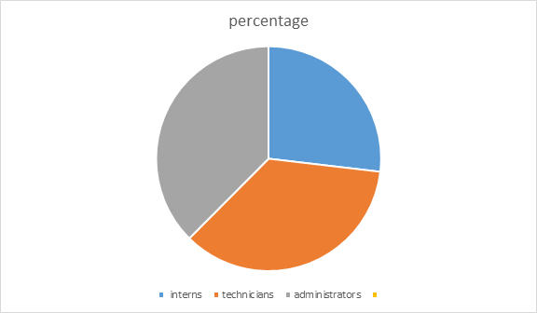

Figure 1: Pie chart showing percentage of respondents by category

ii) Working experience of respondents

Analysis of employee working period DICTS showed that the majority of the respondents (67%) had worked for the organization for a period between 5-15 years, and 33% of the respondents had been in this for less than 5 years.

|  |  |  |
| --- | --- | --- |
| Period worked | Frequency | Percentage |
| Less than 5 | 1 | 33 |
| 5-15 | 2 | 67 |
| Total | 3 | 100 |

Table 2: showing the working experience of respondents used in the project study.

iii) Respondents’ opinions about the current monitoring process.

From the three respondents, two of them said that the current system is poor as it involved manual processes, and one of the respondents said that the system is fair and none of them said that the system is excellent.

|  |  |  |  |
| --- | --- | --- | --- |
|  | Frequency | Percent | Valid percent |
| Poor | 2 | 66.6 | 66.66 |
| Fair | 1 | 33.4 | 33.4 |
| Excellent | 0 | 0 | 0 |
| Total | 3 | 100.0 | 100.0 |

Table 3: Respondent's opinion about the current monitoring system

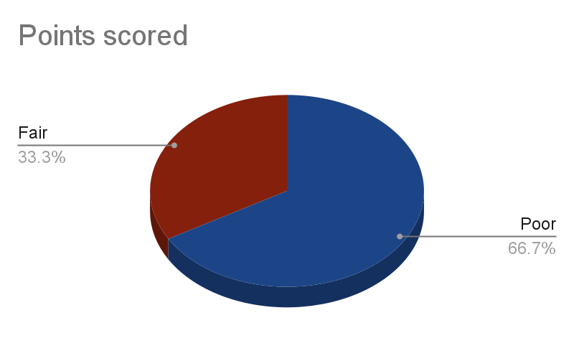

Figure 4: Pie chart showing Respondent's opinion about the current monitoring system

iv) Analysis on the Respondents' opinions about the proposed system.

From the 3 respondents, 66% had an excellent view about the operations of the proposed system, 34% of the respondents said that the system is fair.

|  |  |  |  |
| --- | --- | --- | --- |
|  | Frequency | Percent | Valid percent |
| Excellent | 2 | 66 | 66 |
| Fair | 1 | 34 | 34 |
| Total | 3 | 100.0 | 100.0 |

Table 4: Respondent's opinion about the proposed monitoring system

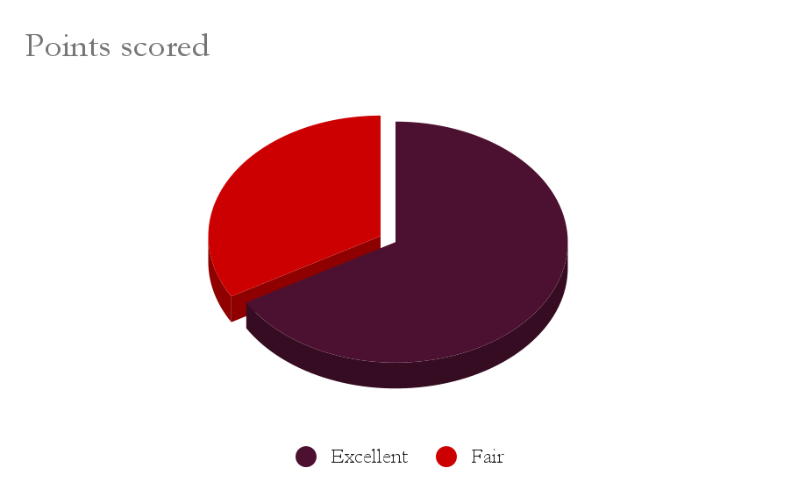

Figure 5: A pie chart showing respondents’ opinion about the proposed monitoring system

vi) Involvement by gender of respondents and methodology.

According to the interview survey conducted at DICTS, 1 respondent was female covering 34% of those interviewed at the data center, while according to the survey conducted by questionnaires all respondents were male covering 66% of the survey. The demographics were as follows:

|  |  |  |  |
| --- | --- | --- | --- |
| Gender | Methodology | Respondents | Percent |
| Female | Interview | 1 | 34 |
| Male | Questionnaires | 2 | 66 |
| Total |  | 3 | 100.0 |

Table 4: Respondent's opinion about the proposed monitoring system

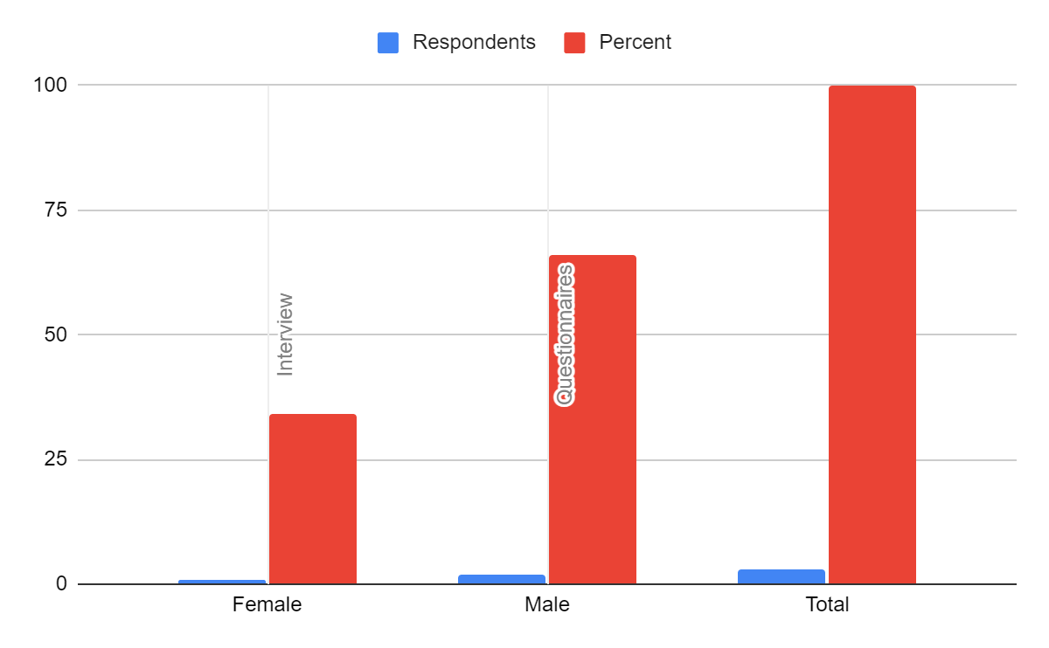

Figure 6: A bar graph showing percentage of involvement by gender

v) Analysis about the challenges faced by the existing system

From the 3 respondents, 2 of them held out that current manual processes were tiresome and time consuming for instance they're required to physically walk in the server room and feel. The end-user administrator one of the respondents had a view that the existing system was prone to liability due to overheating.

Figure 7: A bar graph showing analysis about the challenges faced by the existing system

### 2.2.2 Findings:

The findings revealed that the current manual-based monitoring system is time-consuming and the organization is prone to liabilities. Participants from the server room management expressed the need for a more efficient system that would allow timely alerts to allow real time monitoring of temperature changes in the server room. The main challenges identified embraced that the existing system was hectic, tiresome and can't be monitored remotely which can lead to physical damage of servers thus downtime which interrupts the availability of services at DICTS. Participants recommended the development of a system that can provide real-time temperature readings, timely alerts when the temperature exceeds a predefined threshold to allow users to monitor the temperature history of the server room. Consider the tables below for insight into the findings.

|  |  |  |  |  |  |
| --- | --- | --- | --- | --- | --- |
| Persons interviewed | Gender | How do you currently receive alerts if the server room temperature exceeds the desired range? | Have you experienced any failures with the servers? | What tools or software do you currently use to analyze the data collected from the sensors and how do you manage this data? | What are your expectations for the new server room temperature monitoring system? |
| Interviewee A01 | Male | Manual way detected when I visit the server room | Yes | No software used | Fully functional sensors installed with remote management using software |
| Interviewee B01 | Female |  | Yes |  |  |
| Interviewee A01 | Male | Physically walking in and feel | Yes | Currently no tools automated to do that | Timely alerts |

Table 7: Findings from the different questions asked the personnel (administrators, technicians,) in their respective duties

**Section 3: System User Requirements**

**3.1 Functional requirements.**

* The system should allow for real-time monitoring of the temperature in the server room.
* The system should provide the ability to set temperature thresholds and alerts when the temperature exceeds these thresholds.
* The system should be able to log temperature data over time and provide historical reports on temperature fluctuations.
* The system should provide different access levels to users, with different permissions to view and interact with the data.
* The system should be able to integrate with different temperature sensors, including wireless sensors and wired sensors.
* The system should be able to send alerts via email, SMS, or push notifications to designated recipients when temperature thresholds are breached.
* The system should provide a dashboard that displays key metrics and temperature trends in real-time.

**3.2 Non Functional requirements.**

* The system should be highly reliable and have a high level of uptime to ensure continuous monitoring of the server room temperature.
* The system should be secure and protect user data and system data from unauthorized access and cyber-attacks.
* The system should be easy to use and have a user-friendly interface that is accessible to users with varying levels of technical expertise.
* The system should be scalable and able to handle increasing data volumes and user traffic as the organization grows.
* The system should have good performance and respond quickly to user requests and system events.
* The system should be well documented, with clear instructions on how to use and troubleshoot the system.
* The system should comply with relevant data privacy and security regulations, such as GDPR, HIPAA, or PCI-DSS, if applicable to the organization.

**3.2.1. Software requirements**

* Web-based User Interface: The system should have a user-friendly web-based interface accessible through popular web browsers, including Google Chrome, Firefox, Safari, and Microsoft Edge.
* Real-time Data Display: The system should display the temperature data in real-time with an option to refresh the page.
* Historical Data Storage: The system should store temperature data over time and provide a graphical representation of historical temperature trends.
* Threshold Alerts: The system should allow users to set temperature thresholds and generate alerts when the temperature exceeds these thresholds.
* Notification Alerts: The system should send notifications of temperature alerts through email, SMS, or push notifications.
* User Authentication and Authorization: The system should provide user authentication and authorization to ensure that only authorized users can access the system.
* Role-based Access Control: The system should provide role-based access control, allowing administrators to define user roles and permissions.
* Data Visualization: The system should provide graphical representations of temperature data, including line charts, bar charts, and heat maps.
* Device Integration: The system should integrate with different temperature sensors, including wireless and wired sensors.
* Data Export: The system should provide the ability to export temperature data in different formats, including CSV, Excel, and PDF.
* Security: The system should comply with industry-standard security protocols, including encryption, secure sockets layer (SSL), and two-factor authentication.
* Scalability: The system should be scalable and able to handle large data volumes and increasing user traffic as the organization grows.
* Performance: The system should be optimized for performance and able to handle real-time data processing and visualization.
* Reliability: The system should be highly reliable and have a high level of uptime to ensure continuous monitoring of the server room temperature.
* Support and Maintenance: The system should have a support and maintenance plan, including regular updates, bug fixes, and technical support.

Software needed for the proposed system includes Fritzing for creating the temperature monitoring and control system, Arduino IDE with the necessary libraries for programming the Microcontroller ESP-WROOM32, and cloud platforms (software and APIs) to facilitate data storage.

HTML scripts for relay remote control and PHP scripts for email and SMS notifications can be edited in Sublime Text. ThingSpeak is a cloud platform used to store sensory data, and a website hosting relays is created using the ESP webserver library. ThingSpeak mobile app (Thing View Free) is used for visualizing temperature data in real-time.

**3.2.2 Hardware requirements.**

* Temperature Sensors: A temperature sensor is the most important hardware requirement for the system. The temperature sensors can be either wired or wireless and should be capable of transmitting temperature readings to the server on a continuous basis.
* Gateway: If wireless sensors are used, a gateway device may be required to collect data from the sensors and transmit it to the server. The gateway device should have the capability to connect to the network and communicate with the sensors.
* Server: The server is the central component of the system and should have sufficient processing power and storage capacity to handle real-time monitoring of the server room temperature, store historical data, and generate reports. A dedicated server is recommended for this purpose.
* Network Infrastructure: The system should be connected to a reliable and secure network infrastructure to enable data transmission between the sensors, gateway, and server. The network infrastructure should be able to handle the traffic generated by the system and provide adequate bandwidth for data transfer.
* Uninterruptible Power Supply (UPS): An uninterrupted power supply is recommended to ensure the system remains operational during power outages. The UPS should be capable of providing enough power to keep the system running until power is restored.
* Backup Power Source: A backup power source such as a generator should be available in the event of a prolonged power outage. This ensures continuous monitoring of the server room temperature even during extended power outages.
* Enclosure: The server and gateway devices should be installed in a secure and protected enclosure to prevent unauthorized access and protect against environmental factors such as dust, humidity, and temperature fluctuations.

The hardware tools consist of choosing the proper hardware for developing prototypes, a computer, a mobile device, and other materials.

The suggested system needs automated and remote cooling, temperature monitoring, and a notification mechanism. The prototype therefore needs the ESP-WROOM32 microcontroller, a DHT11 temperature sensor, electrically programmable relays, fans that act as air conditioners, a 12V solar battery, a mobile phone, resistors, jumper wires, a breadboard, and a rooter.

A laptop computer is used to power and program the ESP- WROOM32 board during the system development. In order to share the internet connection (Wi-Fi) with the ESP WROOM board, a mobile device and router utilized as hotspots. As a result, ESP32 transmits temperature sensory data to the cloud to enable data processing and visualization. Additionally, the web based mobile applications and ESP web applications makes cooling devices and remote data viewing possible. Following are the main components for prototyping the project.

(i) The ESP-WROOM32 microcontroller

The ESP32 chip, also referred to as the Microcontroller ESP-WROOM32, is capable of functioning as a full standalone system. According to Foltynek et al. (2019), the chip integrates Wi-Fi, Bluetooth, and additional communication interfaces like SPI and I2C/UART. This microcontroller has certain advantages over others, including the size of the chip, the quantity of pins, and the incorporated Wi-Fi.

The ESP32 DOIT DEVKIT V1 board and the 30 pin versions are the ones utilized to construct the prototype on a breadboard.

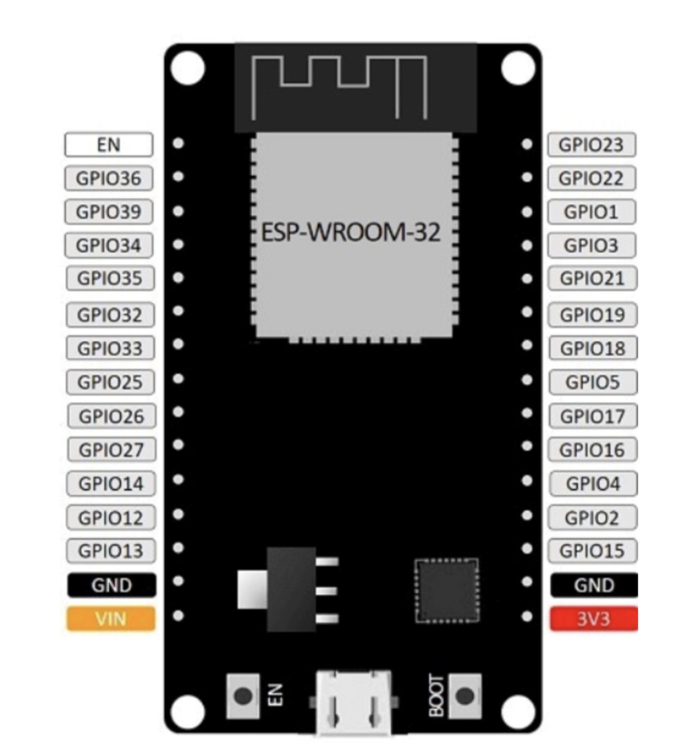

Figure 8: ESP32 DOIT DEVKIT V1 Board version with 30 GPIOs Pinouts

(ii) Digital Temperature and Humidity Sensor

There are numerous temperature sensors that are compatible with development boards like Arduino, ESP32, ESP8266, and others (Santos, 2016). Six commonly used temperature sensors, including the DHT11, DHT22, LM35, DS18B20, BME280, and BMP180, (Santos, 2019).

The best temperature sensor for this project, in terms of characteristics and accuracy, is the DHT22. This sensor can measure temperatures between -40 and 80 degrees Celsius and provides a humidity reading between 0 and 100% with an accuracy of 2 to 5%. (Alvan et al.)

One DHT22 sensor was utilized to obtain the precise temperature data that was then saved to the cloud based on these criteria, the size of the data center room, and the DHT22 sensor. (Lady-ada, 2020).

(iii) Electrical Relays

To control one electrical circuit, relays open and close connections in a different circuit. Relays are programmable switches that cause disruption in the circuit so that users can interact with it and control it from a distance. To open and close circuits, they use electro-mechanical or electrical devices.

**The questionnaire used to collect data**

**A MOBILE PHONE-BASED SERVER ROOM TEMPERATURE MONITORING**

**SYSTEM QUESTIONNAIRE**

Dear Participants,

We’d like to ask you to participate in an essential survey on a mobile phone-based server

room temperature monitoring system. The goal of this survey is to collect important insights

and comments from users like you in order to improve the system’s functioning and usability.

The mobile phone-based server room temperature system is a software program that uses web

technology to monitor temperatures in the server room 24/7 remotely and provide push alerts.

By taking part in this survey, you will be able to share your thoughts and experiences about

the mobile phone-based server room temperature systems. Your input will be utilized to

identify areas for improvement, improve the user experience, and deliver better end-user

services.

The survey responses will be kept private. We respect your feedback and appreciate your

time in taking part in this important survey.

Thank you.

INFORMATION ABOUT CORRESPONDANT.

Names: ………………………………………………………....................................................

Gender: …………………………………………………………………………………………

Occupation: …………………………………………………………………………………....

Responsibility in the server room:

…………………………………………………………………………………………………

…………………………………………………………………………………………………

…………………………………………………………………………………………………

QUESTIONS.

1. How are temperatures in a server room monitored?

…………………………………………………………………………………………………

…………………………………………………………………………………

2. What temperature range do you aim to maintain in the server room?

………………………………………………….............................................................

3. Who is responsible for monitoring the temperature of the server room?

……………………………………………………………………………………….

4. How long have you been working with servers?

…………………………………………………………………………………………..

5. Have you experienced any failures with the servers?

…………………………………………………………………………………………

6. How do you currently receive alerts if the server room temperature exceeds the

desired range?

…………………………………………………………………………………..

7. If yes, what challenges did you face in the current way of receiving alerts?

…………………………………………………………………………………………………

…………………………………………………………………………………………

……………………………………………………………………………

8. How many temperature sensors are needed for the server room?

…………………………………………………………………………………………

9. What tools or software do you currently use to analyze the data collected from the

sensors and how do you manage this data.

…………………………………………………………………………………………………

…………………………………………………………………………………

10. What are your expectations for the new server room temperature monitoring system?

…………………………………………………………………………………………………

…………………………………………………………………………………

11. Is there anything else you would like to add that we have not covered yet?

…………………………………………………………………………………………………

…………………………………………………………………………………

**SYSTEM ARCHITECTURE**

**1.0 Overview of the project**

Temperature rise of a server room is a significant problem, leading to problems like equipment failure and reduced equipment lifespan which in the long run may lead to loss of data. In order to solve this issue, we propose a system for monitoring temperature levels in a server room.

This system aims at providing a providing real time monitoring and control of the temperature within the server room environment.

* 1. **Introduction**

According to Kendall (2005), System Design provides details of how the system met the information requirements as determined by the Analyst. It specifies how the requirements were translated into an Information System (IS) as well as the technologies that were used for construction of the system. It defines how the system works in key areas of the user interface, program modules, security and database structure and transactions.

This System architectural design document focuses on the design and implementation of server room temperature monitoring system. The document encases the system overview, design considerations, assumptions and dependencies, goals and guidelines, constraints, and development methods. It also includes details of system design specifications, description of drawings of the system components, subcomponents, and modules using various diagrams, such as Use Case Diagrams, Data Flow Diagrams, Activity Diagrams and Class Diagram.

**2.0 System overview**

A server room temperature monitoring system provides real-time monitoring and control of the temperature within a server room or data Centre environment. Here's a system overview of how such a monitoring system typically operates:

1. Sensors: The system consists of temperature sensors strategically placed throughout the server room. These sensors continuously measure the ambient temperature and send the data to the monitoring system.
2. Data Collection: The monitoring system collects temperature data from the sensors at regular intervals. The data can be transmitted via wired or wireless connections, depending on the system's design.
3. Data Storage and Processing: The collected temperature data is stored in a database or a centralized storage system. The monitoring system processes the data to analyse trends, calculate averages, and compare the current temperature readings against predefined thresholds or desired temperature ranges.
4. Real-time Monitoring and Alerts: The monitoring system continuously monitors the temperature levels in the server room. It compares the real-time temperature data with the predefined thresholds or ranges. If the temperature exceeds the acceptable limits, the system triggers an alert, which can be sent via email, SMS, or other notification methods to system administrators or facility managers.
5. Visualization and Reporting: The monitoring system provides a user interface or dashboard that displays the real-time temperature readings and historical data. This visualization allows administrators to quickly assess the temperature conditions and identify any potential issues. The system may also generate reports, charts, or graphs to provide insights into temperature trends over time.
6. Configuration and Customization: The monitoring system usually offers configuration options, allowing administrators to set temperature thresholds, define alert criteria, and customize monitoring settings according to their specific needs. This flexibility enables fine-tuning of the system based on the server room's requirements.
7. Integration and Remote Access: Advanced monitoring systems may offer integration capabilities with other infrastructure management tools or building automation systems. This integration allows for centralized monitoring and control of multiple server rooms or data centers. Additionally, the system may provide remote access capabilities, enabling administrators to monitor temperature conditions and receive alerts from anywhere with an internet connection.

**2.0.1 Functionality**

* Real-time Temperature Monitoring: The system continuously monitors the temperature levels in the server room in real-time. It provides accurate and up-to-date temperature readings from multiple sensors placed strategically throughout the environment.
* Threshold Configuration: Administrators can set predefined temperature thresholds or desired temperature ranges within the monitoring system. These thresholds indicate acceptable temperature limits for the server room. If the temperature exceeds or falls below the configured thresholds, the system generates alerts to notify administrators of the temperature anomaly.
* Alerts and Notifications: When temperature readings cross the predefined thresholds, the monitoring system sends out alerts and notifications to designated individuals or groups. These alerts can be delivered through various channels such as email, SMS. Alerts allow administrators to take immediate action to address any temperature-related issues and prevent potential equipment failures.
* Historical Data Logging: The temperature monitoring system records and stores historical temperature data over time. This data logging capability enables administrators to review past temperature patterns, identify trends, and detect any recurring issues or potential risk factors. Historical data is often presented in the form of charts, graphs, or reports to facilitate analysis and decision-making.
* Visualization and Dashboard: The system typically provides a user-friendly interface or dashboard that displays the real-time temperature readings, historical data, and relevant metrics. The dashboard allows administrators to quickly assess the current temperature conditions, view trends, and monitor the overall status of the server room environment at a glance.
* Remote Access: Many temperature monitoring systems offer remote access capabilities, allowing administrators to monitor temperature conditions and receive alerts from anywhere with an internet connection. This feature enables administrators to stay informed and take necessary actions even when they are not physically present in the server room or on-site.

**2.1 Design considerations**

1. Sensor Placement: Proper sensor placement is crucial to accurately monitor temperature conditions in the server room. Sensors should be strategically positioned in areas where temperature variations are most likely to occur, such as near server racks, air conditioning vents, and hot spots. Consider the server room layout, airflow patterns, and potential sources of heat when determining sensor placement.
2. Redundancy: Redundancy is essential to ensure continuous monitoring even in the event of sensor or system failures. Implementing duplicate or backup sensors can provide redundancy and mitigate the risk of inaccurate temperature readings or monitoring system downtime.
3. Scalability: The monitoring system should be designed with scalability in mind to accommodate future growth and changes in the server room environment. It should be capable of easily adding or relocating sensors as needed, without requiring significant system modifications or disruptions.
4. Threshold Configuration Flexibility: The system should offer flexibility in configuring temperature thresholds to accommodate different server room requirements. Administrators should be able to set thresholds at various levels to account for different areas or zones within the server room, as well as different temperature requirements for specific equipment or applications.
5. Alerts and Notifications Customization: Design the monitoring system to allow customization of alerts and notifications. Administrators should be able to specify the recipients of alerts, the communication channels to be used, and the severity levels or escalation paths for different temperature events. This flexibility ensures that the right people receive timely alerts and can take appropriate actions.
6. Integration Capabilities: Consider the ability of the temperature monitoring system to integrate with other infrastructure management tools or systems. Integration can provide centralized monitoring and control, streamline workflows, and enable automated actions or responses based on temperature events. Integration with building management systems or data center management platforms can enhance overall monitoring and operational efficiency
7. Security: Security is a critical aspect of any monitoring system. Implement measures to protect the system from unauthorized access, ensure data privacy, and secure communication between sensors, the monitoring system, and any integrated platforms.

**2.2 Assumptions and Dependencies**

**Assumptions**

* The server room temperature monitoring system assumes that the temperature sensors used in the monitoring system are accurate and provide reliable temperature readings.
* The server room temperature monitoring system assumes that the temperature sensors are strategically placed in the server room to capture representative temperature readings.
* The system assumes that the predefined temperature thresholds set by the administrators accurately represent the acceptable temperature ranges for the server room.
* The server room temperature monitoring system assumes that the alerting and notification mechanism of the temperature monitoring system is properly configured and functioning effectively.

**Dependencies**

1. The system depends on stable an uninterruptible power supply to operate.
2. The system depends on a robust network infrastructure for data transmission between the temperature sensors and the monitoring system itself.
3. The system depends on the proper functioning and accuracy of the temperature sensors.
4. The system also depends on the responsiveness and actions taken by the administrators or operators responsible for monitoring and managing temperature conditions.

**2.3 General Constraints.**

**Cost constraints**

The system design and implementation must adhere to a predetermined budget. This constraint may impact the selection of sensors, monitoring equipment, and integration capabilities.

**Legal and regulatory constraints**

The monitoring system should comply with relevant industry standards, regulations, and data protection requirements. Constraints may arise from data privacy regulations, security protocols, or environmental regulations.

**Scalability constraints**

The system should be scalable to accommodate future growth or changes in the server room environment. It should be capable of expanding the number of sensors, accommodating additional monitoring points, and handling increased data volume without significant modifications or disruptions.

**User interface constraints**

Constraints related to user accessibility and training may be present. The monitoring system should have a user-friendly interface and be designed with the knowledge and skill level of the intended users in mind. Adequate training and documentation should be provided to ensure effective utilization of the system.

**Time constraints**

The design of the system will be measured by time limits, such as the need to launch the system within a specific timeframe or to meet a regulatory deadline.

**Technical constraints**

The monitoring system should be compatible with existing server room infrastructure, including networking equipment, power supply systems, and cooling systems. Integration with other systems, such as building management systems or data center management platforms, may also be subject to technical compatibility constraints.

**Space Limitations**

Server rooms often have limited space available for additional equipment. The monitoring system should be designed with consideration for physical space constraints, ensuring that it can be implemented without significantly impacting the server room's layout or functionality.

**Power and Network Availability**

The monitoring system's implementation may be constrained by the availability and reliability of power supply and network connectivity in the server room. It must be able to function even during power outages or network disruptions.

**Goals and Guidelines**

Overall, the design Goals of the proposed system should prioritize the needs of users, ensuring that the system is user-friendly, secure, transparent, reliable, scalable, compliant, efficient, and well-integrated, timely alerting, etc.

**2.4 Goals and Guidelines**

Overall, the design Goals of the proposed system should prioritize the needs of users, ensuring that the system is user-friendly, secure, transparent, reliable, scalable, compliant, efficient, and well-integrated, timely alerting, etc.

Guidelines for the system may include adhering to best practices for system development methodologies as well as ensuring compliance with relevant regulations and standards.

**User-friendly interface**

The system should have an intuitive user interface and be easy to navigate and operate. It should provide clear and easily understandable temperature readings, alerts, and historical data. User-friendly features include customizable dashboards, simplified configuration settings, and easy access to relevant information.

**Reliability**

Ensure the system's reliability by using accurate and properly calibrated temperature sensors, robust data transmission protocols, and redundant components. The system should be capable of continuous monitoring and withstand potential disruptions, such as power outages or network failures.

**Transparency**

Provide transparency in terms of the system's operation and functionality. Users should have visibility into how temperature readings are collected, thresholds are set, and alerts are generated. Clear documentation and system documentation should be provided to help users understand the system's capabilities and limitations

**Scalability**

Design the system with scalability in mind to accommodate future growth and changing requirements. It should be capable of easily adding or relocating temperature sensors, expanding the monitoring capacity, and integrating with additional server rooms or data centers without significant modifications.

**Security**

Implement robust security measures to protect the system from unauthorized access and ensure the privacy and integrity of temperature data. This includes user authentication, data encryption, access controls, and monitoring of system logs for suspicious activities.

**Compliance**

Ensure the system complies with relevant industry standards, regulations, and data protection requirements. This includes adhering to privacy regulations, maintaining audit trails, and implementing necessary security controls to protect sensitive temperature data.

**Efficiency and reporting**

Optimize system efficiency by minimizing resource utilization, such as power and network bandwidth. Implement data compression techniques, optimized data storage, and intelligent data sampling to reduce storage requirements while maintaining the accuracy of temperature readings.

**Integration**

Design the system to seamlessly integrate with other infrastructure management tools, building automation systems, or data center management platforms. Integration enables centralized monitoring and control, streamlines workflows, and enhances cross-platform visibility.

**Timely Alerting**

Ensure that the system provides timely and accurate alerts when temperature thresholds are breached. Alerts should be customizable, allowing users to specify recipients, severity levels, and notification channels. The system should support notifications through various channels like email, SMS, and push notifications.

**2.5 Development Methodology**

**2.5.1 Agile development methodology**

The agile method is a popular approach to software development that emphasizes flexibility and collaboration throughout the development process. It is characterized by a focus on iterative, incremental development, with frequent testing and feedback from stakeholders.

In the context of building a web-based server room temperature monitoring system, an agile approach would involve breaking the development process into smaller, more manageable tasks or "sprints." Each sprint would focus on a specific aspect of the system, such as designing the user interface or implementing the temperature monitoring functionality.

Throughout each sprint, the development team would work closely with stakeholders, such as the system administrators who will be using the system, to gather feedback and make adjustments as needed. This feedback loop is a key feature of the agile approach, as it helps to ensure that the final product meets the needs of its intended users.

Another important aspect of the agile approach is the use of automated testing and continuous integration, which allows the development team to quickly identify and fix bugs as they arise. This helps to ensure that the final product is of high quality and that any issues are addressed in a timely manner.

Overall, the agile method of system development is a flexible and collaborative approach that can be well-suited to building a web-based server room temperature monitoring system. By breaking the development process into smaller sprints and working closely with stakeholders, the development team can ensure that the final product meets the needs of its intended users and is of high quality.

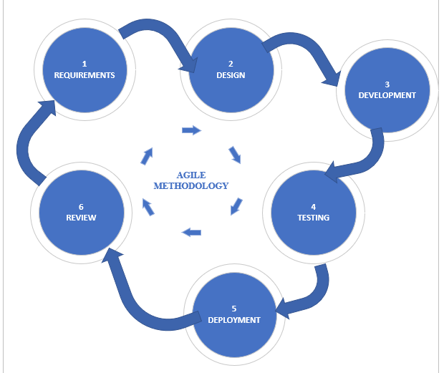

*Figure 1.showing agile methodology*

**2.5.2 Reasons why we used agile method of system development.**

* Iterative development: The agile method involves breaking down the development process into small, incremental steps called sprints. Each sprint produces a working piece of the system that can be tested and reviewed by stakeholders. This iterative approach allows for changes and improvements to be made quickly and efficiently.
* Flexibility: The agile method is highly adaptable to changes in requirements or priorities. As the development team learns more about the system and user needs, they can adjust the plan and make changes to the product backlog. This flexibility can be especially helpful when building a system that needs to be able to handle unexpected changes or updates.
* Customer involvement: Agile development emphasizes collaboration and communication between the development team and the customer or end user. This involvement helps to ensure that the system meets the needs and expectations of its intended users. For a temperature monitoring system, it's especially important to understand the specific needs and requirements of the server room environment.
* Faster time to market: By breaking down development into smaller sprints, the agile method can help speed up the time it takes to deliver a working product. This can be especially valuable in industries where timing is critical, such as in data center operations.
* Continuous testing and integration: The agile method encourages continuous testing and integration throughout the development process. This helps to catch any issues or bugs early on, which can save time and resources in the long run.

**3.0 Detailed Systems Design.**

The system design section of this report provides a detailed overview of the architecture and functionality of a web-based server room temperature monitoring system. This system is designed to enable efficient monitoring of the temperature levels in a server room, providing real-time data to prevent potential damage to critical IT equipment and ensure optimal performance.

The system incorporates a variety of hardware and software components, including temperature sensors, microcontrollers, web servers, and databases. The system also utilizes a range of communication protocols, including Wi-Fi, HTTP, and MQTT, to facilitate data transfer between various components.

This section of the report will explore the system design in detail, including the system architecture, hardware and software components, communication protocols, and data management strategies. Additionally, it will discuss key design considerations, such as scalability, reliability, and security that were taken into account during the development process.

**3.1 Architectural design of the system**

In this section, we will discuss the detailed system design for building a web-based server room temperature monitoring system. This system is designed to monitor the temperature of server rooms and alert the system administrator in case of any temperature deviations. The system consists of hardware and software components that work together to achieve its objectives.

**Hardware Components**:

The following hardware components are required for the system to function:

* Temperature sensors: These are sensors that measure the temperature of the server rooms. They will be placed in different locations within the server room to ensure that the temperature is accurately monitored.
* Microcontroller: A microcontroller will be used to collect data from the temperature sensors. It will also be responsible for sending this data to the server through the internet.
* Server: A server will be used to store the data collected by the microcontroller. It will also be responsible for sending alerts to the system administrator in case of temperature deviations.
* Temperature Sensors: A temperature sensor is the most important hardware requirement for the system. The temperature sensors can be either wired or wireless and should be capable of transmitting temperature readings to the server on a continuous basis.
* Gateway: If wireless sensors are used, a gateway device may be required to collect data from the sensors and transmit it to the server. The gateway device should have the capability to connect to the network and communicate with the sensors.
* Server: The server is the central component of the system and should have sufficient processing power and storage capacity to handle real-time monitoring of the server room temperature, store historical data, and generate reports. A dedicated server is recommended for this purpose.
* Network Infrastructure: The system should be connected to a reliable and secure network infrastructure to enable data transmission between the sensors, gateway, and server. The network infrastructure should be able to handle the traffic generated by the system and provide adequate bandwidth for data transfer.
* Uninterruptible Power Supply (UPS): An uninterrupted power supply is recommended to ensure the system remains operational during power outages. The UPS should be capable of providing enough power to keep the system running until power is restored.
* Backup Power Source: A backup power source such as a generator should be available in the event of a prolonged power outage. This ensures continuous monitoring of the server room temperature even during extended power outages.
* Enclosure: The server and gateway devices should be installed in a secure and protected enclosure to prevent unauthorized access and protect against environmental factors such as dust, humidity, and temperature fluctuations.

The hardware tools consist of choosing the proper hardware for developing prototypes, a computer, a mobile device, and other materials.

The suggested system needs automated and remote cooling, temperature monitoring, and a notification mechanism. The prototype therefore needs the ESP-WROOM32 microcontroller, a DHT11 temperature sensor, electrically programmable relays, fans that act as air conditioners, a 12V solar battery, a mobile phone, resistors, jumper wires, a breadboard, and a rooter.

A laptop computer is used to power and program the ESP- WROOM32 board during the system development. In order to share the internet connection (Wi-Fi) with the ESP WROOM board, a mobile device and router utilized as hotspots. As a result, ESP32 transmits temperature sensory data to the cloud to enable data processing and visualization. Additionally, the web based mobile applications and ESP web applications makes cooling devices and remote data viewing possible. Following are the main components for prototyping the project.

(i) The ESP-WROOM32 microcontroller

The ESP32 chip, also referred to as the Microcontroller ESP-WROOM32, is capable of functioning as a full standalone system. According to Foltynek et al. (2019), the chip integrates Wi-Fi, Bluetooth, and additional communication interfaces like SPI and I2C/UART. This microcontroller has certain advantages over others, including the size of the chip, the quantity of pins, and the incorporated Wi-Fi.

The ESP32 DOIT DEVKIT V1 board and the 30 pin versions are the ones utilized to construct the prototype on a breadboard.

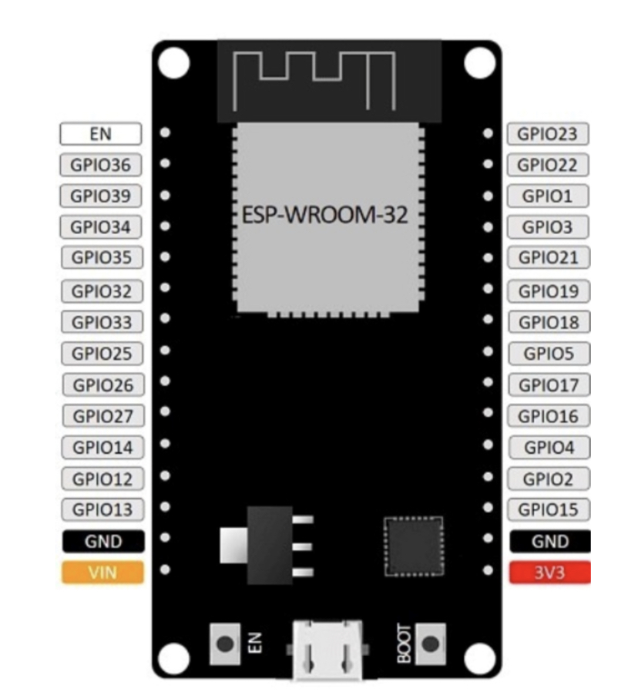

Figure 8: ESP32 DOIT DEVKIT V1 Board version with 30 GPIOs Pinouts

(ii) Digital Temperature and Humidity Sensor

There are numerous temperature sensors that are compatible with development boards like Arduino, ESP32, ESP8266, and others (Santos, 2016). Six commonly used temperature sensors, including the DHT11, DHT22, LM35, DS18B20, BME280, and BMP180, (Santos, 2019).

The best temperature sensor for this project, in terms of characteristics and accuracy, is the DHT22. This sensor can measure temperatures between -40 and 80 degrees Celsius and provides a humidity reading between 0 and 100% with an accuracy of 2 to 5%. (Alvan et al.)

One DHT22 sensor was utilized to obtain the precise temperature data that was then saved to the cloud based on these criteria, the size of the data center room, and the DHT22 sensor. (Lady-ada, 2020).

(iii) Electrical Relays

To control one electrical circuit, relays open and close connections in a different circuit. Relays are programmable switches that cause disruption in the circuit so that users can interact with it and control it from a distance. To open and close circuits, they use electro-mechanical or electrical devices.

**Software Components**:

The following software components are required for the system to function:

1. Firmware: Firmware will be developed for the microcontroller to collect data from the temperature sensors and send it to the server. The firmware will be responsible for ensuring that the data is accurate and reliable.
2. Database: A database will be used to store the data collected by the microcontroller. The database will be responsible for storing the temperature data and generating reports.
3. Web Application: A web application will be developed to allow the system administrator to monitor the temperature of the server rooms in real-time. The web application will be accessible through a web browser and will display the temperature data in a graphical format. The application will also be responsible for sending alerts to the system administrator in case of temperature deviations.

Software needed for the proposed system includes ngrok for creating the temperature monitoring and control system, Arduino IDE with the necessary libraries for programming the Microcontroller ESP-WROOM32, and cloud platforms (software and APIs) to facilitate data storage.

HTML scripts for relay remote control and PHP scripts for email and SMS notifications can be edited in Sublime Text. ThingSpeak is a cloud platform used to store sensory data, and a website hosting relays is created using the ESP webserver library. ThingSpeak mobile app (Thing View Free) is used for visualizing temperature data in real-time.

**System Architecture:**

The following is the proposed system architecture for the web-based server room temperature monitoring system:

1. The temperature sensors will be connected to the microcontroller.
2. The microcontroller will collect data from the temperature sensors and send it to the server through the internet.
3. The server will store the data in the database and generate reports.
4. The web application will be developed to allow the system administrator to monitor the temperature of the server rooms in real-time. The application will also be responsible for sending alerts to the system administrator in case of temperature deviations.

**3.2 Flow chart diagram**

Once built, every component of the system must function in accordance with Fig. A temperature monitoring system starts the operation, and the cooling and notification system responds in accordance with the detected data. Every time, the sensed data is transferred to the cloud for analysis and visualization.

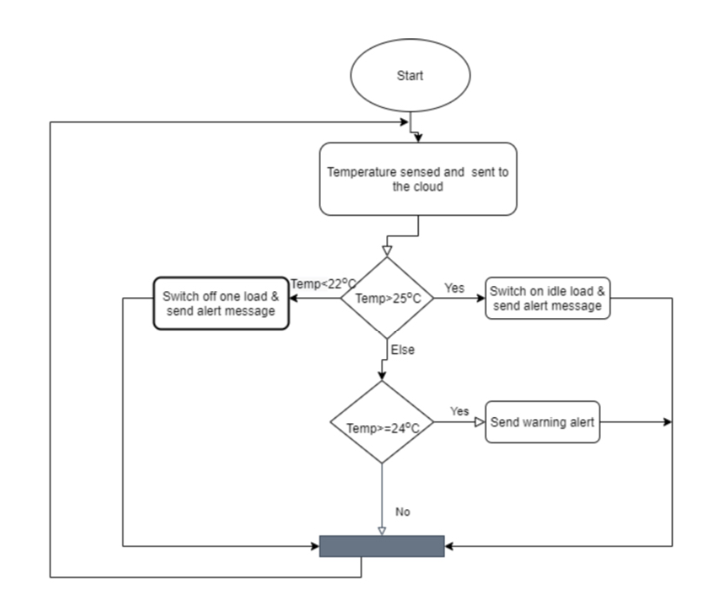

*Figure 2 showing a flow chart diagram*

**3.2 Activity Diagram.**

3.3 Process Design

The process design will be done carefully with the efficiency and effectiveness as the primary objective. The efficiency with which system resources are used and the effectiveness with which the software is written to achieve the efficiency is the most important consideration.

Below are the symbols used in the processing modelling;



External Entity

process

Data flow

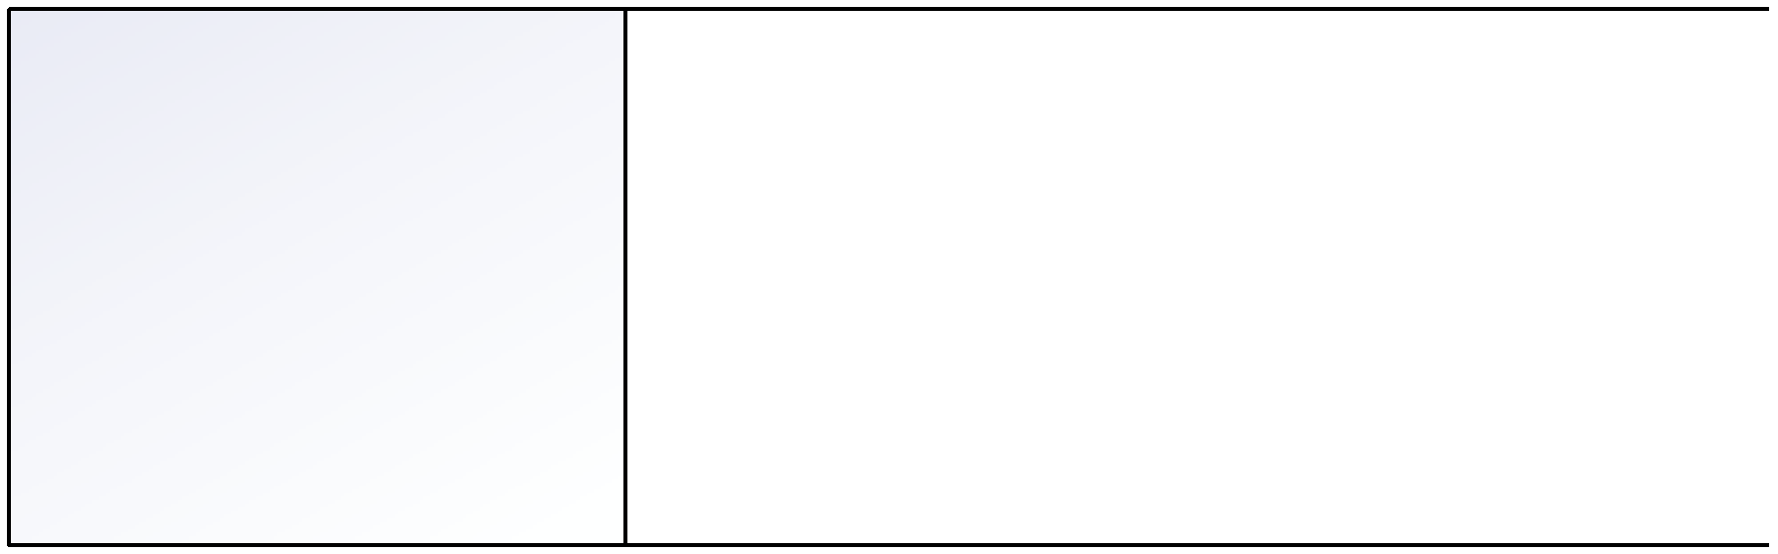

Data store

**Data flow diagrams.**

A data flow diagram is a visual module showing the flow of data through a process or a system, the data flow diagram shows where data comes and goes from, activities transforming data, output stored in the system and output utilized by other activities/entities. For a server room temperature monitoring system, for a web based server room temperature monitoring system, we are going to have our data flow diagrams showcased in two levels that is to say the level zero and level one.

**Context diagram (level 0)**

The context zero diagram provides an over view of the system and its external entities. It illustrates how the system interacts with external entities without going through the internal details. Here is a context zero diagram for a web based server room temperature monitoring system. In the context zero diagram, the sever room is the source of the temperature data, the monitoring system collects and processes the data, and sends notifications to the email and SMS gateways of the authorized users.

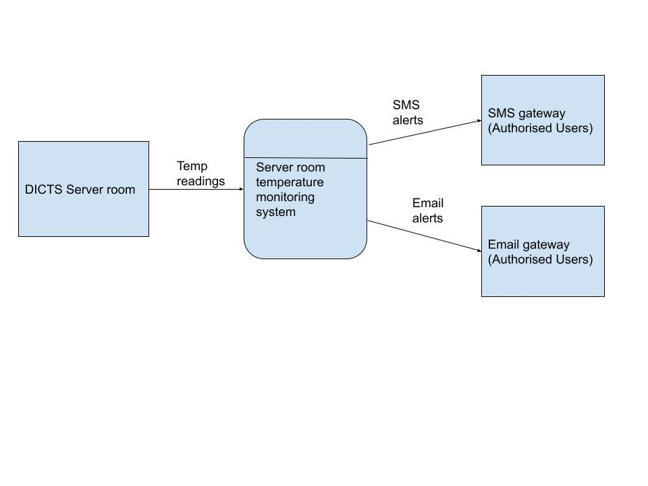

**LEVEL 1 Diagram**

The diagram represents a web-based server room temperature monitoring system. The Server Room entity generates temperature data, which flows into the Monitoring System. The data goes through processes such as receiving the temperature, processing it, and generating alerts if thresholds are exceeded. The processed data is stored in a Data Store. The Notification System sends notifications to Authorized Users when alerts are triggered. The User Management process handles user authentication and authorization. Overall, the system ensures continuous monitoring of the server room temperature, providing real-time alerts to authorized users for efficient temperature management.

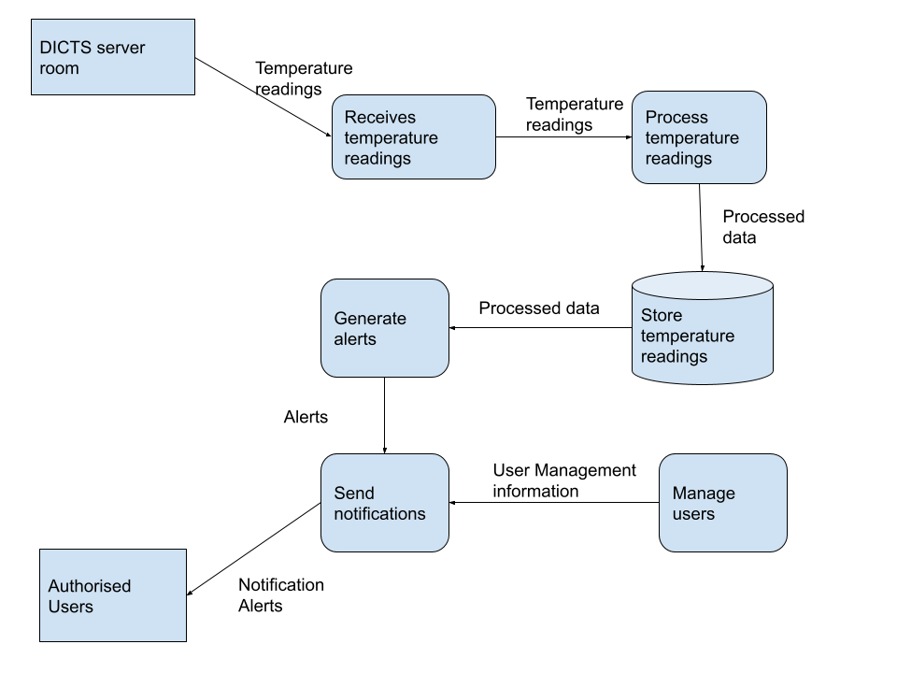

**High level architecture design.**

The high-level architecture of the web-based server room temperature monitoring system consists of several components. In the server room, there is a DHT11 sensor connected to an ESP32 microcontroller. The ESP32 records the temperature readings from the DHT11 sensor. The ESP32 is connected to a router, enabling it to transmit the temperature data over the internet. The data is sent to a web-based database where it is stored for future retrieval. A web server hosts the application, providing the user interface for clients to access temperature readings and configure alerts. The system includes an email and SMS alerting system, which integrates with the web server to send notifications to clients when temperature thresholds are exceeded. This architecture enables clients to remotely monitor the server room temperature and receive alerts through email and SMS notifications.

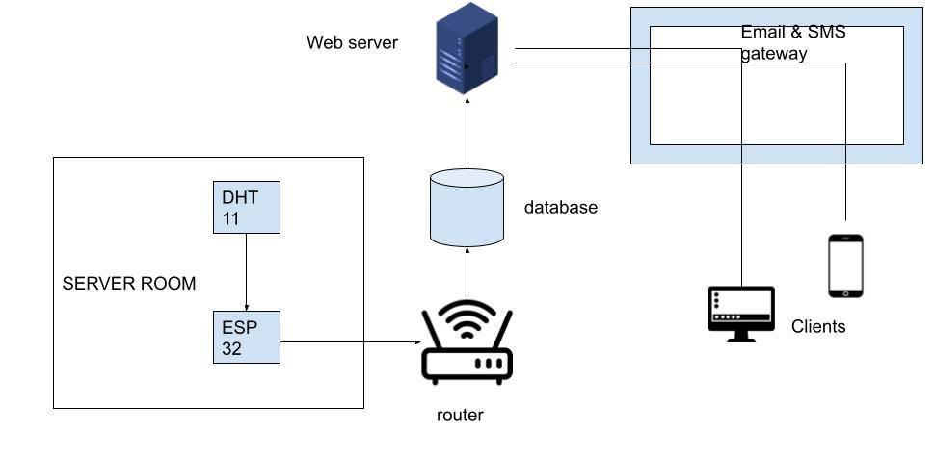

**Use case Diagram.**

Use-case diagrams describe the high-level functions and scope of a system. These diagrams also identify the interactions between the system and its actors. In the case of a serve room temperature monitoring system, the actors include authorized users and the system admin, the user can only view the current temperature data and also view historical data, the admin however can do all that the user can do but with the privilege of being able to make modification on who can become a user.

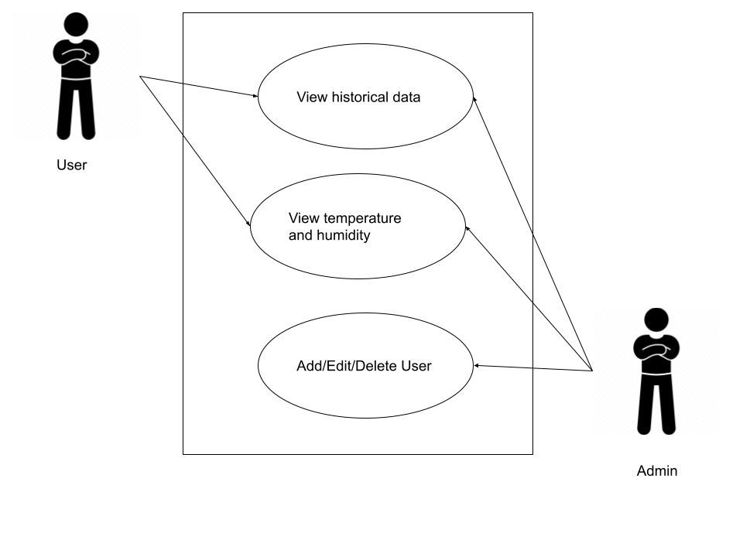

**Class diagram**

The class diagram is a powerful tool for visualizing the relationships between objects in a software system. In the case of a web-based server room temperature monitoring system, the class diagram shows how various components of the system interact with each other. This includes the web application, database, and sensor interfaces. By providing a clear picture of the system's structure, the class diagram helps developers and stakeholders understand how the system works and how it can be maintained and improved over time.

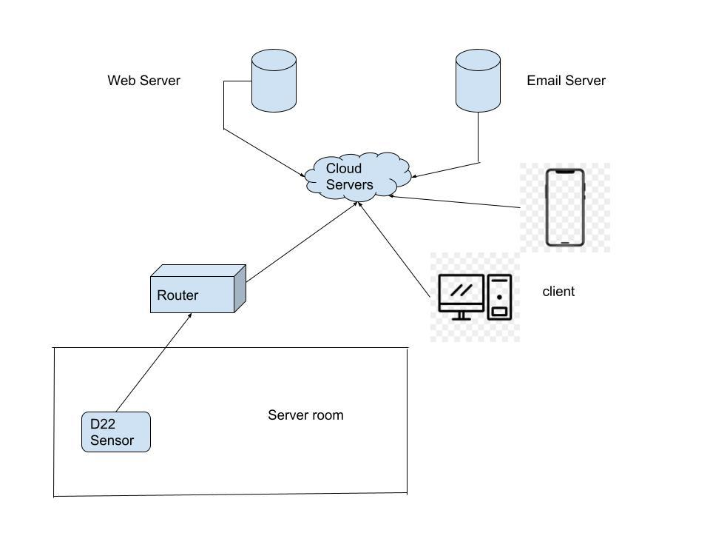

**Activity diagram**

This activity diagram illustrates the step-by-step process for monitoring the temperature of a server room through a web-based system. The diagram outlines the activities and actions involved in gathering temperature data, transmitting it to the web-based server, and displaying it in real-time to authorized users. By following this diagram, the monitoring process can be streamlined and automated, ensuring that critical temperature thresholds are maintained and the server room environment remains stable.

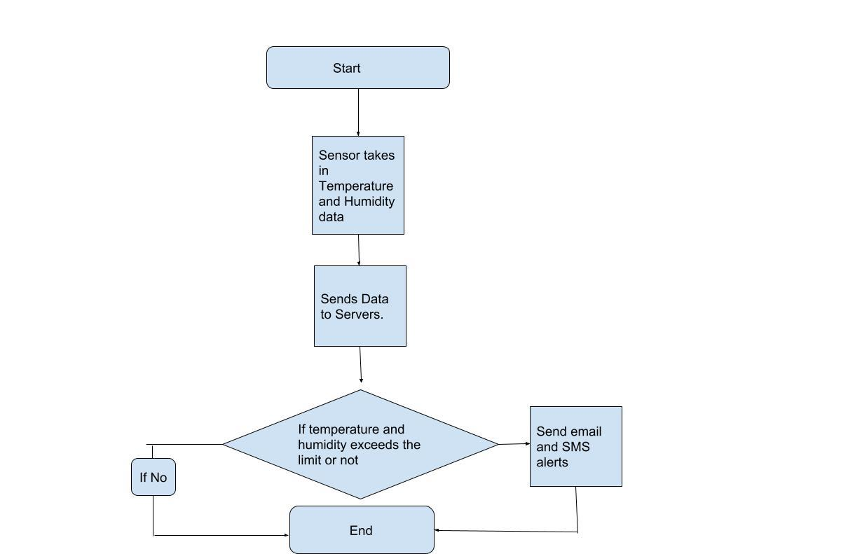

**Sequence diagram**

The sequence diagram represents the step-by-step process of the web-based server room temperature monitoring system. Firstly, the client accesses the system by visiting the web application hosted on the web server. The client interacts with the web application, configuring alert thresholds and preferences, and submits the changes. The web server receives and processes the client's request, storing the configuration data in the database. Simultaneously, the ESP32 microcontroller continuously reads temperature data from the server room and sends it to the web server. The web server receives the temperature readings and stores them in the database for historical records. It periodically checks the temperature against the configured thresholds and, if breached, triggers a notification request to the email/sms service. The email/sms service then sends an alert message to the client, notifying them of the temperature breach. This detailed process ensures continuous monitoring of the server room temperature, allowing clients to configure personalized alerts and receive timely notifications.

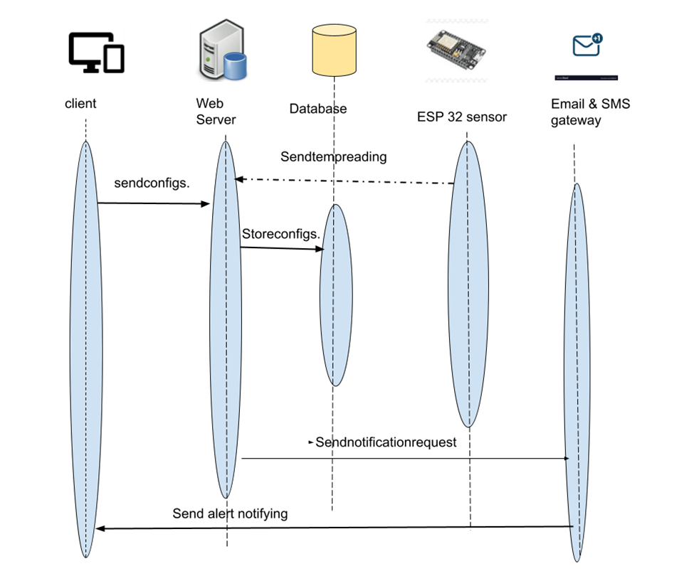

**Data Modelling.**

A data model is a formal way of representing the data that is used and created by the system. It shows the places, people and things in which the data captured and the relationships among them.

This section talks about relationship modelling between entities and cardinalities between entities and the can be the following.

* One to one relationship
* One to many relationships
* Many to many relationships

1. User to sensor

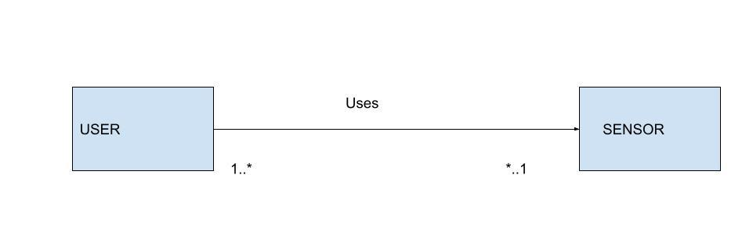

Many to many relationships. Users can be assigned to multiple sensors and sensors can be associated with multiple users. This represents ownership/Access control relationship.

1. Sensor to server room

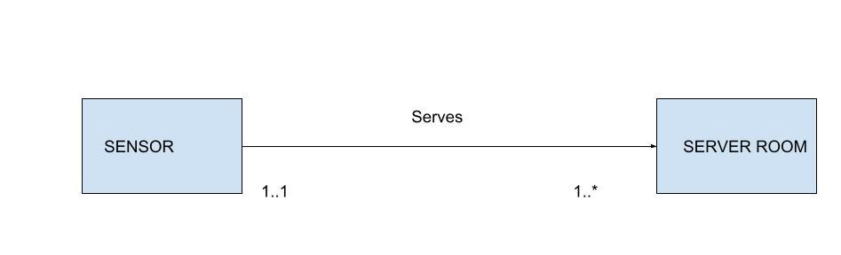

Many to one relationship. Multiple sensors can belong to single server room, but each sensor is associated to one sensor.

1. Alert to sensor

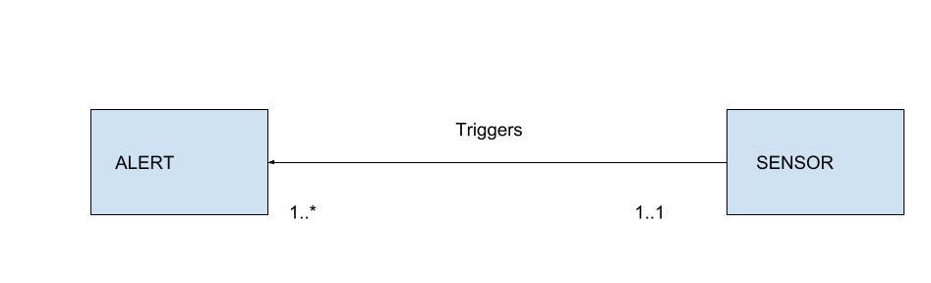

Many to one relationship. Each alert is triggered by a specific sensor when a temperature thresh hold is breached.

1. Log to sensor

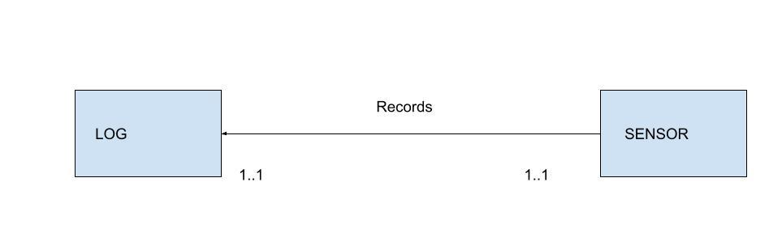

Many to one relationship. Each temperature log is associated with a specific sensor that recorded the temperature reading.

1. Server room to threshold

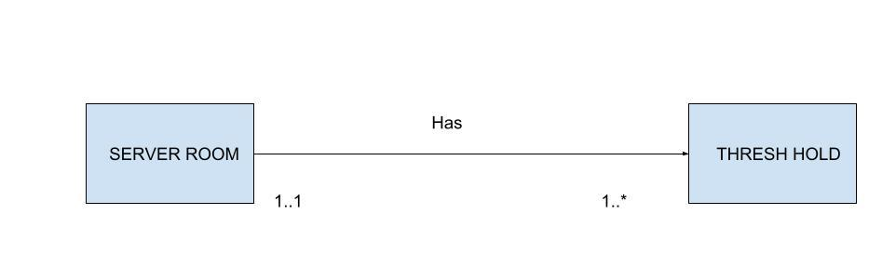

Each server room can have multiple temperature thresh holds but each threshold is specified to a single thresh hold

1. Integration platform to sensor

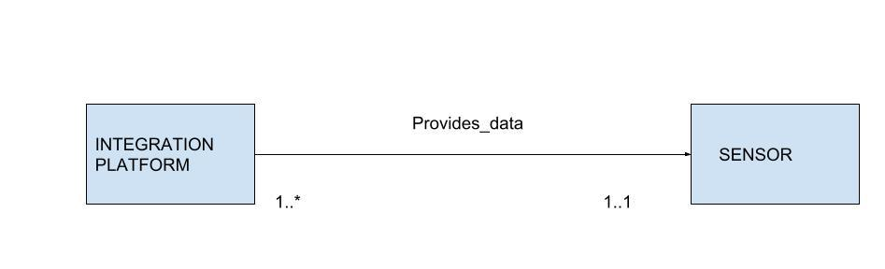

Many to many relationships. Many to many relationship, multiple integration platforms can be associated with multiple sensors, and each sensor can be integrated with multiple platforms.

**Entity Relationship Diagram.**

An Entity Relationship Diagram (ERD) is a visual representation of the relationships between different entities within a system. In the context of a web-based server room temperature monitoring system, the ERD can provide a clear overview of how the various components of the system interact with each other. By mapping out the relationships between entities such as sensors, servers, and users, the ERD can help to ensure that the system is designed and implemented correctly. This can ultimately lead to a more efficient and effective system that meets the needs of stakeholders and end-users alike.

**Entity Relationship Diagram.**

An Entity Relationship Diagram (ERD) is a visual representation of the relationships between different entities within a system. In the context of a web-based server room temperature monitoring system, the ERD can provide a clear overview of how the various components of the system interact with each other. By mapping out the relationships between entities such as sensors, servers, and users, the ERD can help to ensure that the system is designed and implemented correctly. This can ultimately lead to a more efficient and effective system that meets the needs of stakeholders and end-users alike.

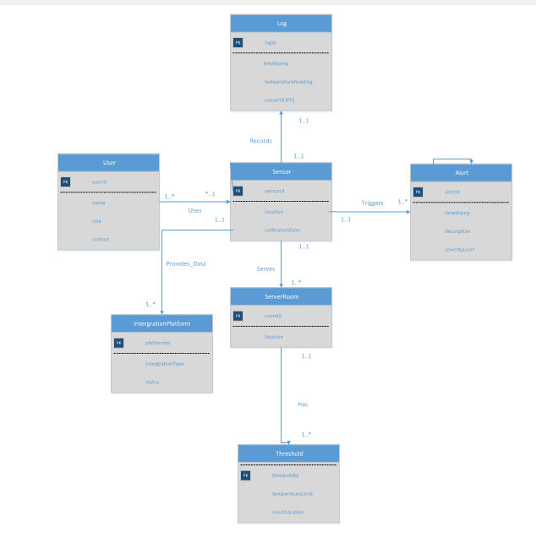

**Glossary**

|  |  |
| --- | --- |
| **Activity diagram** | Shows the various activities involved in the creation, distribution, verification, and alert generation processes. |
| **Agile** | The ability to move quickly or swiftly. |
| **Agile methodology** | A flexible and iterative approach to software development that emphasizes collaboration, and continuous improvement. |
| **Alert** | Is a notification message in form of sound, pop up that is unexpected by the user indicating something has gone wrong. |
| **Architecture attacks** | The nonfunctional business requirements that influence the system requirements that drive the design of the system. |
| **Assumptions** | Are an individual judgment and opinion of the expected outcome. |
| **Authentication** | The process of verifying the authenticity of a product or service. Using a unique username and password to access the system. |
| **Constraints** | Is a condition, restriction, or requirement that the system must satisfy. For example, a constraint might involve maximums for one or more resources, such as time, dollars, or people |
| **Cyber-** | Unauthorized access or use of computer systems or networks. |
| **Data** | Un-meaningful facts and figures without context. |
| **Data flow** | Is a path for data to move from one part of the information system to another? |
| **Data Flow Diagram (DFD)** | Shows how data moves through an information system but does not show program logic or processing steps. A set of DFDs provides a logical model that shows what the system does, not how it does it |
| **Data privacy** | protection of sensitive information or data from unauthorized access |
| **Data store** | Is used in a DFD to represent data that the system stores because one or more processes need to use the data at a later time. |
| **Design** | Is a visual layout of the development architecture of a system. |
|  |  |
| **Efficiency** | Achieving desired results while using or inputting less effort. |
| **Feedback** | Is a response, an opinion, and comment about the system reaction after use. |
| **Flexibility** | Ability to change with ease in a given situation or environment. |
| **Flow chart** | an activity diagram that shows the various activities involved in the creation, distribution, verification, and alert generation processes |
| **Guidelines** | Are the standards, rules that must be followed in the development of the server room temperature monitoring system. |
| **Identify** | Establish or indicate who or what (someone or something) is. |
| **Information** | Refers to meaningful data with context. |
| **Interfaces** | Refers to display forms, images, storyboards, workspaces, dashboards as prototype template designs of a system. |
| **Methodology** | Refers systematic process followed to achieve a given goal of system development. |
| **Regulatory** | Person or an organization responsible for registering or removing manufacturers from the supply chain, and also offers trading licenses. |
| **Risk** | An unexpected event occurring resulting into two outcomes; positive and negative. |
| **Scalability** | The ability of a system to handle increasing amounts of data and users without compromising its functionality the ability of a system to support multiple users and large data sets with time in the future. |
| **Security** | Measures to ensure the confidentiality, integrity, and availability of the data. |
| **Sequence diagram** | Diagram that describes how and in what order a group of entities interact timely with each other. |
| **System** | A set of interconnected components that work together to achieve a specific goal. |
| **Team** | A group of people working together on a project to achieve a similar goal. |
| **Time constraints** | The need to launch the system within a specific timeframe or to meet a regulatory deadline. |
| **Transparent** | The openness and clarity of the system's operations and transactions. |
| **Use case diagram** | Shows the different actors and their interactions with the system. |
| **User-friendly** | The ease with which users can interact with and use the system. |

**Citation**

[1]Alvan, P. U., Aziz, A., Winarno, & Harjito, B. (2019). Server Room Temperature & Humidity Monitoring Based on Internet of Thing (IoT). Journal of Physics: Conference Series, 1306(1). https://doi.org/10.1088/1742-6596/1306/1/012030

[2]Association, G. (2014). Understanding the Internet of Things (IoT). GSMA Connected Living, 1(July), 13.

Sari, M., & Sadikin, N. (2019). Server Temperature Monitoring [3]System Using Web Based Censor and SMS Gateway. Journal of Physics: Conference Series, 1361(1), 012026 IOP Publishing. https://doi.org/10.1088/1742-6596/1361/1/012026

[4] J. P. SIPAN, "Temperature & Humidity Monitoring & Control System Based On Arduino And Sim900a Gsm Shield," International Journal Of Electrical, Electronics And Data Communication, Vol. 5, No. 11, P. 62, 2017.

[5] S. A. Nugroho, " Detektor Suhu Ruangan Dengan Tombol Pengatur Manual Berbasis Mikrokontroler AT89S51," Seminar Riset Unggulan Nasional Informatika Dan Komputer FTI UNSA, Vol. II, No. 2, Pp. 15-21, 2013.

[6] Santos, S. (2019). DHT11 vs DHT22 vs LM35 vs DS18B20 vs BME280 vs BMP180 | Random Nerd Tutorials. https://randomnerdtutorials.com/dht11-vs-dht22-vs-lm35-vs- ds18b20-vs-bme280-vs-bmp1

[7] T. Liu, "Digital-Output Relative Humidity & Temperature Sensor/Module DHT22 (DHT22 Also Named As AM2302)," Aosong Electronics Co.,Ltd.

[8] A. H. Saptadi, "Perbandingan Akurasi Pengukuran Suhu Dan Kelembaban Antara Sensor DHT11 Dan DHT22," Jurnal Infotel , Vol. VI, No. 2, Pp. 49-55, 2014.